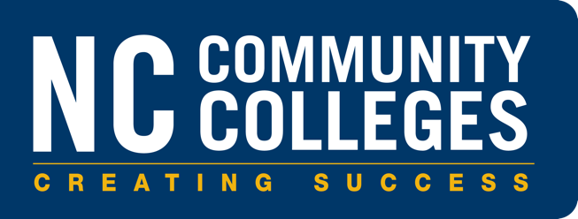

Building Careers

Construction Alignment Project   
Request for proposals

Proposals are due by   
June 13, 2023

Programs & Student Services Division

North Carolina Community Colleges System Office

5001 Mail Service Center

Raleigh, NC 27699-5001   
[NCCommunityColleges.edu](https://www.nccommunitycolleges.edu/)

Project Overview  
The construction trades industry is a high-demand career field in North Carolina. To support the growing needs in North Carolina, the State Board of Community Colleges approved the allocation of $60,000 to be used for the Building Careers Alignment Project from funds provided by the 2021 Appropriations Act (Session Law 2021‐180) SECTION 24.1D.(a).

The Building Careers Alignment Project Overview: $60,000 will be allocated to a lead college to support an industry informed alignment project focused on updating and aligning curriculum credit and short-term workforce development construction course offerings at community colleges. The lead college will be responsible for convening faculty groups from community colleges across the system and industry partners to examine course and program alignment with industry recognized credentials in curriculum Construction Technologies programs and Workforce Continuing Education courses. Funds may be used for travel costs and overload instructional contracts for faculty involved in the project. The product of the Building Careers Alignment Project may result in the revision of existing curriculum courses and/or curriculum standards and/or the creation of new curriculum courses to meet the current needs of construction industry employers.

## Eligibility

To be eligible to receive this funding, a college must meet both of the following criteria:

* College must be currently approved to offer one or more curriculum Construction Technologies program(s) (35XXX).
  + College must currently offer a minimum of one Workforce Continuing Education Construction courses.

## Important Dates and Milestones

|  |  |
| --- | --- |
| Dates | Milestones |
| May 30, 2023 | System Office sends out the Request for Proposals (RFP). |
| June 13, 2023 | Applications are due to the System Office.  Please submit a **Word document** to **all** of the following email addresses**:**  [PSS-RFPs@nccommunitycolleges.edu](mailto:PSS-RFPs@nccommunitycolleges.edu)  [gardnera@nccommunitycolleges.edu](mailto:gardnera@nccommunitycolleges.edu)  [eadsl@nccommunitycolleges.edu](mailto:eadsl@nccommunitycolleges.edu)  [boyceb_tmp@nccommunitycolleges.edu](mailto:boyceb_tmp@nccommunitycolleges.edu)  [lairm@nccommunitycolleges.edu](mailto:lairm@nccommunitycolleges.edu) |
| June 19, 2023 | System Office convenes review team to make recommendations to Senior Leadership Team. |
| June 23, 2023 | Lead college approved by the System President. |
| June 26, 2023 | Lead college notified of funding award. |
| July 1, 2023 | Project begins. |
| September 1, 2023 | Quarterly Report Due. |
| December 1, 2023 | Quarterly Report Due. |
| March 1, 2024 | Quarterly Report Due. |
| June 3, 2024 | Quarterly Report Due. |
| September 2, 2024 | Quarterly Report Due. |
| December 1, 2024 | Final continuing education and/or curriculum course requests and/or curriculum standard revisions to be submitted to the System Office by close of business December 1, 2024. (Course requests and/or curriculum standard revisions may be submitted earlier throughout the project as work is completed.)  **Note that funds must be obligated (i.e., costs must be incurred) by December 31, 2024 and expended by December 31, 2026.** |

## NCCCS Contacts

|  |  |
| --- | --- |
| Dr. Andrew Gardner AVP of Workforce Strategies [gardnera@nccommunitycolleges.edu](mailto:gardnera@nccommunitycolleges.edu) | Dr. Lisa Eads AVP of Academic Programs  [eadsl@nccommunitycolleges.edu](mailto:eadsl@nccommunitycolleges.edu) |
| Barbara Boyce Workforce Consultant [boyceb_tmp@nccommunitycolleges.edu](mailto:boyceb_tmp@nccommunitycolleges.edu) | Michelle Lair Director of Academic Programs [lairm@nccommunitycolleges.edu](mailto:lairm@nccommunitycolleges.edu) |

## Alignment Project Standards

Each proposed project **must** include the following:

1. ***Professional development activities*** for faculty working with the programs covered by this project. These activities must include in-service training for faculty in curricula where industry needs and/or emerging technologies have brought about changes in course and/or program content.
2. ***Plan for curriculum development, dissemination, and field testing***, especially for curricula that integrate new content with technical and academic methodologies, and curricula that provide a coherent sequence of courses through which occupational and academic skills may be measured.
3. **A*ssessment of programs****,* including the development of industry-driven performance standards and measures and program improvement and accountability.

The programs and activities designed to meet these standards shouldinclude the promotion of partnerships among employers, education (including educational agencies and higher education institutions), industry, labor, community-based organizations, and/or governmental agencies; the support of technical student and/or faculty organizations, leadership, and instructional programs in technology education; and data collection. Colleges are requested to submit proposals that provide statewide leadership in enriching and updating the curricula covered in this project and offered at the North Carolina Community Colleges across the state.

## Budget Constraints

A maximum award of $60,000 will be awarded to one college for the grant period. Expenditures of these funds must be used only to support approved project objectives and outcomes.

1. **Budget for Faculty Training:** A minimum of **30 percent** of the total budget must be used for items of direct benefit to participating colleges.
2. **Faculty In-service Training:** The budget must include travel and subsistence for at least one faculty member, from every North Carolina community college offering the targeted curricula or instructional area, to attend professional development activities and to participate in curriculum development activities.
3. **Equipment:** Furniture and office equipment may not be funded by this project.
4. **Time Frame****:** The requested proposed budget will provide funding for appropriate activities that occur between **July 1, 2023 – December 31, 2024**. The *Required Budget Form (Attachment A)* will identify the use of these funds.
5. **Contingency of Funds****:** The allocation of these funds is contingent upon the availability of funds.
6. **Funds Management****:** Funds must be used in accordance with the NCCCS Accounting Procedures Manual.

## Proposal Development Guidelines

To receive grant funding, the proposal must follow the guidelines and requirements included in this document. The proposal should provide a straightforward and concise description of activities planned to satisfy the requirements of this Request for Proposal (RFP). Emphasis should be placed on completeness and clarity of content. All information requested must be submitted.

## Proposal Development Categories and Review Criteria

All proposal narrative descriptions **must** address the following categories:

* + **Project Design and Implementation Plan (25 points)**
  + **Outcomes/Project Evaluation (25 points)**
  + **Leadership, Capacity, and Commitment (25 points)**
  + **Budget and Budget Narrative (25 points)**

*(See Attachment B for more information)*

## Instructions:

This template is divided into four sections: 1) Project Design and Implementation Plan 2) Outcomes/Project Evaluation 3) Leadership, Capacity, and Commitment and 4) Budget and Budget Narrative. Please respond to the questions contained in each section.

**Please Note:**

|  |
| --- |
| **Applications are due to the System Office by June 13, 2023.**  Please submit a **Word document** to **all** of the following email addresses:  [PSS-RFPs@nccommunitycolleges.edu](mailto:PSS-RFPs@nccommunitycolleges.edu)>  [gardnera@nccommunitycolleges.edu](mailto:gardnera@nccommunitycolleges.edu)  [eadsl@nccommunitycolleges.edu](mailto:eadsl@nccommunitycolleges.edu)  [boyceb_tmp@nccommunitycolleges.edu](mailto:boyceb_tmp@nccommunitycolleges.edu)  [lairm@nccommunitycolleges.edu](mailto:lairm@nccommunitycolleges.edu) |

|  |  |
| --- | --- |
| **Building Careers Alignment Project RFP** | |
| **College Full Name** |  |
| **Primary Contact** |  |
| Name: |  |
| Title: |  |
| Email Address: |  |
| Phone Number: |  |

|  |  |
| --- | --- |
| **Curriculum Program(s) College is Approved to Offer**> | **Workforce Continuing Education Courses College Currently Offers** |
| Example:  Carpentry (Diploma) (D35180) | Example:  CAR-3112 Building Construction Trades |
|  |  |
|  |  |
|  |  |
|  |  |
|  |  |
|  |  |
|  |  |
|  |  |
|  |  |
|  |  |

* If applicable, insert additional rows.

**Please read and attest by entering a “Yes” response in the appropriate boxes.**

This RFP has been reviewed by the following:

|  |  |
| --- | --- |
|  | Response |
| College President |  |
| Chief Financial Officer |  |
| Senior Program Leader with oversight of the Construction Program/Courses |  |

### Section 1: Project Design and Implementation Plan (25 Points)

##### Project Objectives

Describe the project objectives and activities including organized curriculum development activities, targeted professional development activities in curriculum-content updating, methodology training, and emerging technology training (i.e., use of simulation tools, etc.).

##### Faculty and Employer Involvement

Describe your plan for involving faculty from other colleges in achieving project goals and objectives; and a plan for developing partnerships with appropriate agencies and employers to achieve project goals within the defined timeline of the project.

##### Outreach and Recruitment

What are your proposed outreach and recruitment activities? Please include your strategies for serving historically underserved, marginalized, or adversely affected groups. How will your program address equity and inclusion?

##### Student Support Services

What support services will you provide to students that address removing barriers that impede their progress and completion of your construction training program?

If applicable, provide a list of internal/ external partnerships that you use to provide support services to students enrolled in your construction training program.

### Section 2: Outcomes/Project Evaluation (25 Points)

Based on the project design, identify the anticipated outcomes and detailed evaluation methods of this project, including measurable outcomes, such as faculty training materials and workshops; alignment of the programs identified for this project; curriculum materials to be developed; and involvement of faculty from across the state.

Identify the expected long-term benefits of the project to the community college system, such as training and developing faculty; development of networks and support groups; seamless articulation/transferability between secondary schools and community colleges; fundamental changes in instructional delivery methods; revised instructional materials derived from instructors' classroom-based research; and/or a program of study which better prepares students for the workplace.

### Section 3: Leadership, Capacity, and Commitment (25 Points)

Provide evidence of the college's capacity and commitment to launch and manage this statewide project. Describe the college's own program and innovative strategies that have been implemented to enhance instruction in the targeted curriculum area. Identify the proposed program liaison and explain his/her capabilities to provide statewide leadership. If a program liaison has not been determined, please include a detailed description of the required qualifications for the liaison. (This should be placed at the end of the proposal as an attachment and is the only attachment page allowed in the proposal.) Describe the involvement of the college's academic and administrative leadership in providing oversight, supervision, and support for project activities.

### Section 4: Budget and Budget Narrative (25 Points)

Provide a detailed budget narrative describing considerations of cost-effectiveness and involvement of faculty from across the state in planning and implementing activities designed to achieve the project's goals. In addition to the budget narrative, complete Attachment A - the Required Budget Template.

## 

## Appendix A: Required Budget Template

|  |  |  |  |
| --- | --- | --- | --- |
| **NORTH CAROLINA STATE BOARD OF COMMUNITY COLLEGES** | | | |
| **NORTH CAROLINA COMMUNITY COLLEGE SYSTEM** | | | |
| **PROPOSED BUDGET** | | | |
|  | | | |
| **PROJECT TITLE** | | | |
|  | | | |
| **ORGANIZATION NAME & FEDERAL ID #** | | | |
|  | | | |
| **EFFECTIVE DATES** | | | |
|  | | | |
| Upon recommendation of the North Carolina Community College System, the following budget is allotted for the above indicated purpose and period. Please do not add any additional items to the list of costs below. | | | |
|  | | | |
|  | **Coordination Costs** |  |  |
| A. | Instructional Supplies and Materials |  | $ - |
|  |  |  |  |
| B. | Printing (Meeting Materials) |  | $ - |
|  |  |  |  |
| C. | Contractual Services |  | $ - |
|  |  |  |  |
| D. | Faculty Travel (Transportation & Subsistence) |  | $ - |
|  |  |  |  |
| E. | Curriculum Development |  | $ - |
|  |  |  |  |
| F. | Faculty Preparation and Professional Development |  | $ - |
|  |  |  |  |
|  | **Total** |  | $ - |
|  |  |  | |
|  | CHIEF FISCAL OFFICER DATE |  | |
|  |  |  | |
|  | CHIEF ADMINISTRATIVE OFFICER DATE |  | |
|  | ***Signatures are required.*** |  | |

## Appendix B: Building Careers Alignment Project RFP Rubric *(Provided for Reference)*

|  |  |  |
| --- | --- | --- |
| **Evaluation Criteria** | Max Points | Points Awarded |
|  | | |
| Section 1: Project Design and Implementation Plan (25 points) | | |
| * Project objectives include a detailed description of curriculum development activities and targeted professional development activities. Steps to implement the proposal are logical, clear, and sufficiently detailed to indicate likelihood of success, including a timeline that demonstrates an understanding of the complexities of orchestrating all elements of the project. Plan for developing partnerships with appropriate agencies and/or employers is defined clearly. | 15 |  |
| * Outreach and recruitment activities include strategies for serving historically underserved, marginalized, or adversely affected groups to promote equity and inclusion. Student support services are clearly detailed in the project plan. | 10 |  |
| Section 2: Outcomes/Project Evaluation (25 Points) | | |
| * Project plan includes detailed evaluation method, including measurable outcomes such as faculty training materials and workshops; alignment of the programs identified for this project; curriculum materials to be developed; and involvement of faculty from across the state. | 15 |  |
| * Long-term benefits of the project are clearly identified and include a detailed description of the benefits to the system, faculty, stakeholders and students.. | 10 |  |
| Section 3: Leadership, Capacity, and Commitment (25 points) | | |
| * Evidence of the college's capacity and commitment to launch and manage this statewide project is provided. Project liaison identified. Involvement of the college's academic and administrative leadership in providing oversight, supervision, and support for project activities clearly described. | 15 |  |
| * Examples provided in the project plan which detail the college's own program and innovative strategies that have been implemented to enhance instruction in the targeted curriculum area. | 10 |  |
| Section 4: Budget and Budget Narrative (25 points) | | |
| * Budget narrative includes a description of the considerations of cost-effectiveness and involvement of faculty from across the state in planning and implementing activities designed to achieve the project's goals. | 15 |  |
| * Required budget template completed and signed by CFO and CAO. | 10 |  |
| Grand Total: | 100 |  |

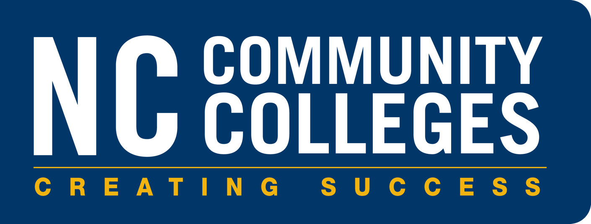

Programs & Student Services Division

North Carolina Community Colleges System Office

5001 Mail Service Center

Raleigh, NC 27699-5001

[NCCommunityColleges.edu](https://www.nccommunitycolleges.edu/)