**College Budget and Accounting System (CBAS) Access Request Process**

1. To process a CBAS access request, users must have a valid ServiceNow user ID. The information within the user ID is used to pre-fill data on the request form. If a ServiceNow user ID has not been assigned to the user, one must be obtained through the process: [Register for the NCCCS Service Portal (servicenowservices.com)](https://ncccs.servicenowservices.com/sys_attachment.do?sys_id=7c6317d11b021510ba075538624bcbc4&view=true). Users should access the ServiceNow portal at <https://ncccs.servicenowservices.com/sp> to place a ticket within ServiceNow to become a registered user. Once users have a valid ServiceNow user ID, they can proceed with completion of the request.
2. Once in ServiceNow, users should click on Request Something on the right side of the ServiceNow home page.





1. Next users should click on Colleague Account Access Request under Category on the left side of the page.

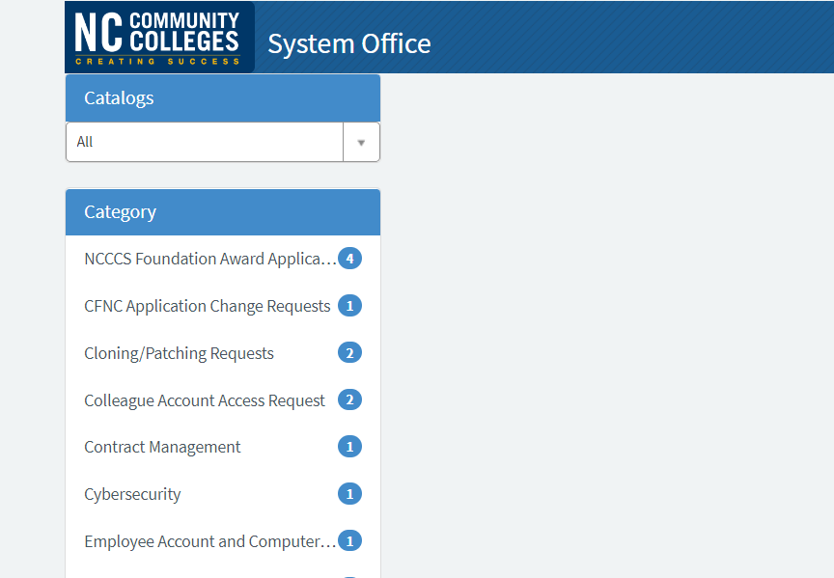

1. On the next screen, users should choose Colleague Account Access in the box on the left side of the page. This will bring up the form to be completed for CBAS access.

1. First, users should choose the appropriate Access Type using the dropdown menu – New User Account, Deactivate User Account or Update Access.



1. Next, users should Select Colleague account you are requesting access to using the dropdown menu – this provides a list of various accesses available. In this instance, users should choose CBAS (the first choice).



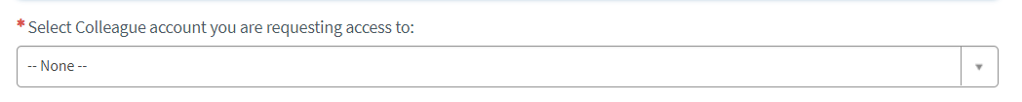



1. Users should List additional access you are requesting or changing - complete the write in box. If accesses should mirror an employee, be sure to include this information. Be sure to include CBAS cash certification.

1. Approving Manager – managers are requested to approve the user request. Choose the approving manager name, then information will pre-fill based on the registered user information for the approving manager. If the approving manager is not a current registered user, they must use the link above to become a registered user in ServiceNow.

1. Requesting users should review the information listed under Colleague Employee Information for Account Access and complete information in the non-shaded boxes.

1. Additional comments or notes can be entered at the bottom of the form.

1. This completes the original request by the user for CBAS access.

Based on information in Item 8 above, the Approving Manager will receive an email from IT Service Desk Requested item RITM1234567 – Approval Request. The highlighted number is used by IT to track and tie appropriate approvals to this request.

1. The email to the approving manager will contain information in summary for the request requiring approval. Below is a copy of an email example.

From: IT Service Desk <[ncccs@servicenowservices.com](mailto:ncccs@servicenowservices.com)>   
Sent: Wednesday, November 9, 2022, 8:55 AM  
To:

Subject: Requested Item RITM1234567 - Approval Request

 Change Type:

Short Description: Request access to CBAS – Name of Requester

Priority: 4 - Low

Category:

 Comments:

Click here to view Requested Item: LINK

Click here to approve RITM1234567

 Click here to reject RITM1234567

 Approval Activity:

You are the sole approver.

1. The approving manager can click on LINK to view the requested item. It is recommended the approving manager review the details within the request.
2. If the approving manager approves the request, they should click on the following: Click here to approve RITM1234567. This will create an email approval back to the System Office IT to proceed with the set up.
3. If the approving manager does not approve the request, they should click on the following: Click here to reject RITM1234567.

Once the request is approved by the approving manager, an email is sent to the Systems Accounting office for approval. Systems Accounting reviews the request and clicks the appropriate CBAS access choices. Once approved by Systems Accounting, the form is submitted to System Office IT for finalization and user ID user.

System Office IT processes the User ID request for CBAS and will call the User and provide the User ID and temporary password.