There will be terminology used in this lesson plan that treats the North Carolina State Highway Patrol and the former NCDMV License and Theft Bureau as one and the same, as well as the titles “Commissioner” and “Commander,” due to the ongoing transition of duties, responsibilities, and leadership structure between these entities. This approach will be used until all related legislation and structural changes are fully enacted.

Title: North Carolina State Safety Inspection Procedures

Lesson Purpose: To present a standardized method of testing and evaluating the performance and knowledge of Inspector- Mechanics conducting North Carolina State Safety Inspections.

Student Performance Objectives: At the end of this block of instruction, the student will be able to achieve the following objectives in accordance with the information received during the instructional period.

- List the eleven inspection areas inspector mechanics must check during a safety inspection.

- Identify eight emission control devices installed by vehicle manufacturers.

- Determine what emissions control devices are required on a vehicle by using the Emission Control System Applications Manual.

- Calibrate and utilize a headlight aimer.

- Achieve a score of 80% or higher on a Highway Patrol approved written exam.

Hours: Eight (8)

Instructional Method: Lecture / demonstration / practical exercise

Classroom Environment: Academic classroom/automotive service bay

Materials required: Pen/pencil
Note paper
Lesson outline
Safety Inspection/Emission Inspection Regulations
Emission Control System Application Manual

Training Aids: PowerPoint Presentation
Approved light testing device
Approve tint meter
Emission Control Manual

References: North Carolina General Statute, Chapter 20
North Carolina Administrative Code, 19A

Study Assignment: None

Prepared By: J. Loyd Crissman
Assistant Supervisor
NCDMV License and Theft Bureau
Date Revised: January 2013

Revised By: Brad Brantley
Assistant Supervisor
NCDMV License & Theft Bureau
Date Revised: February 2014

Revised By: Michael E. Horne
Inspector
NCDMV License & Theft Bureau
Date Revised: August 2015

Revised By: L. Paul Jelley
Assistant Supervisor
NCDMV License & Theft Bureau
Date Revised: August 2016

Revised By: L. Paul Jelley
Assistant Supervisor
NCDMV License & Theft Bureau
Date Revised: January 2017

Revised By: L. Paul Jelley
Assistant Supervisor
NCDMV License & Theft Bureau
Date Revised: January 2018

Revised By: L. Paul Jelley
Assistant Supervisor
NCDMV License & Theft Bureau
Date Revised: January 2019

Revised By: L. Paul Jelley
R.A Rodriguez
Assistant Supervisor
NCDMV License & Theft Bureau
Date Revised: December 2019

Revised By: L. Paul Jelley
R.A Rodriguez
Assistant Supervisor
NCDMV License & Theft Bureau
Date Revised: December 2020

Revised By: L. Paul Jelley
R.A Rodriguez
Assistant Supervisor
NCDMV License & Theft Bureau
Date Revised: December 2021

Revised By: L. Paul Jelley
R.A Rodriguez
Assistant Supervisor
NCDMV License & Theft Bureau
Date Revised: February 2022

Revised By: L. Paul Jelley
R.A Rodriguez
Assistant Supervisor
NCDMV License & Theft Bureau
Date Revised: December 2022

Revised By: L. Paul Jelley
Assistant Supervisor
NCDMV License & Theft Bureau
Date Revised: December 2023

Revised By: B. L. Wall
L. Paul Jelley
Assistant Supervisor
NCDMV License & Theft Bureau
Date Revised: December 2024

Revised By: B.L. Wall
Assistant Supervisor
NC DMV – License & Theft Bureau
Date Revised: February 2025

Revised By: B. L. Wall
L. Paul Jelley
Sergent
NC Highway Patrol ISU
Date Revised: December 2026

- Introduction

A. Opening Statement

This block of instruction is designed to provide the necessary skills for the perspective Inspector-Mechanic to obtain certification to properly conduct a North Carolina Safety Inspection in accordance with the rules and regulations outlined in 19A of the North Carolina Administrative Code and North Carolina General Statutes.

NC DMV - License & Theft merger to NC State Highway Patrol - Investigative Services Unit

There will be terminology used in this lesson plan that treats the North Carolina State Highway Patrol and the former NCDMV License and Theft Bureau as one and the same, as well as the titles “Commissioner” and “Commander,” due to the ongoing transition of duties, responsibilities, and leadership structure between these entities. This approach will be used until all related legislation and structural changes are fully enacted.

B. Opening Statement

There are approximately 38,000 certified Inspection Mechanics performing state safety inspections at over 6,200 Official Inspection Stations in North Carolina. These inspections, when performed properly, help ensure the safety of vehicles traveling on our highways by removing unsafe motor vehicles. These unsafe vehicles may not renew their registration until the identified deficiencies are corrected. If these inspections were not required, drivers could be operating
vehicles upon the roads and highways of our state with potential hazards that could jeopardize the safety of themselves and fellow motorists. To prevent this, the State of North Carolina enacted legislation in 1964 requiring motor vehicles registered in this state to be inspected for safety equipment compliance on an annual basis.

C. Course Objective
At the end of this block of instruction, the student will be able to achieve
the following objectives in accordance with the information received during
the instructional period.

1. List the eleven inspection areas inspector mechanics must check during a
Safety inspection.

2. Identify safety items required for an NC Safety Inspection.

3. Determine what emissions control devices are required on a vehicle during
a safety test by using the Emission Control System Applications Manual.

4. Calibrate and utilize a headlight aimer.

5. Achieve a score of 80% or higher on a NC Highway Patrol approved written
exam.

- Body

- Station Qualifications - 19A NCAC 03D.0519

1. An Inspection Station is a place of business legally licensed by the Commissioner of Motor Vehicles to conduct inspections of motor vehicles as required by North Carolina General Statute. Each Inspection Station must be equipped with the proper equipment and tools in order to perform inspections, which include the following:

a) One (1) jack or lift with a minimum capacity of two (2) tons.
b) One (1) headlight tester to fit all headlights (mechanical, optical, or wall chart.) (See approved headlight testers, appendix)
c) One (1) workbench

d) One (1) creeper

e) One tire tread depth gauge (calibrated in 32nds of inch).

f) One Emissions Control Systems Application Manual or current computerized electronic software.

g) One approved Analyzer with current software.

h) One active dedicated telephone line (Broadband Connection) with internet access for Web Safety.

NOTE: Each licensed inspection station should display
the Official Safety and OBD Procedure Posters, station
license and fee chart in the waiting room or at the cash register.

- Inspection Mechanic Qualifications

To obtain certification to perform North Carolina Safety Inspections the perspective technician must meet all of the following requirements for initial and continued certification:

1. Attend and pass an eight-hour Approved Safety Inspection Course offered by a North Carolina Community College and pass a written examination with a score of no less than 80 percent correct answers. No oral exams shall be allowed.

2. Have a driver’s license that is valid in North Carolina.

3. Be of good character and have a reputation for honesty be able to successfully pass a background check as required by the NC Highway Patrol.

NOTE: Applicants who are denied licensing because of prior criminal history
will have the opportunity to submit documentation to the Licensing Review
Board before final determination is made. The applicant will be notified in
writing of the outcome of the review board.

NOTE: Safety Certifications are valid for (4) years unless otherwise
suspended or revoked by the NC Highway Patrol.

NOTE: An Out of State driver’s license is acceptable if the Inspector-
Mechanic resides in another state.

C. Inspection Fees

North Carolina General Statute 20-183.7 dictates when a fee applies to an
inspection of a vehicle and the issuance of an electronic inspection
authorization.

- The fee for performing an inspection of a vehicle applies when an inspection is performed, regardless of whether the vehicle passes the inspection. The fee for an electronic inspection authorization applies when an electronic inspection authorization is issued to a vehicle. No taxes, shop fees or credit card processing fees can be added to the cost of an inspection, unless other services are provided.

- The following fees apply to an inspection of a vehicle and the issuance of an electronic inspection authorization:

Type Inspection Authorization Total
Safety Only $12.75 $ .85 $13.60

Vehicles Currently Subject to a Safety Inspection Only:

* All Vehicles that are within the three most recent model years AND have
LESS THAN 70,000 miles.

* All Vehicles newer than 30 years old (Date manufactured)

* All Vehicles with Farm Tags.

* Electric / Plug in Vehicles. (Does not have the ability to be propelled by gasoline
Or diesel fuel)

* Trailers with a gross weight of 4,000 pounds or more.

* Vehicles with a GVWR of more than 8,500 pounds.

* Low Speed Vehicles registered for highway use require a safety only inspection. A
low-speed vehicle is a four wheeled vehicle that the top speed is greater than
20 mph but less than 25 mph. (Gas or Electric)

* Modified Utility Vehicles as defined by Nc General Statute 20-4.01(27) requires a Safety Only Inspection and should be classified as an SUV in the analyzer.

* All Vehicles more than 20 years old of the current year model and less than 30 years old from the current model year in any county requires a Safety Only Inspection.

Only Vehicles registered in one of the counties listed below will be subject to the
emission inspection requirements in addition to safety:

Alamance Buncombe Cabarrus Cumberland
Davidson Durham Forsyth Franklin
Gaston Guilford Johnston Lincoln
Mecklenburg New Hanover Randolph Rowan
Wake Union Iredell

SL2023-134 Changes – (Upon aproval from the EPA)

REDUCE EMISSIONS INSPECTIONS REQUIREMENTS

SECTION 12.7.(a) G.S. 20‑183.2(b) reads as rewritten:

"(b) Emissions. – A motor vehicle is subject to an emissions inspection in accordance with this Part if it meets all of the following requirements:

(3) It is (i) a vehicle with a model year within 20 years of the current year and older than the three most recent model years or (ii) a vehicle with a model year within 20 years of the current year and has 70,000 miles or more on its odometer.

(3a) It is a vehicle with a model year within 20 years of the current year and earlier than the 2017 model year.

SECTION 12.7.(b) G.S. 143‑215.107A(c) reads as rewritten:

"(c) Counties Covered. – Motor vehicle emissions inspections shall be performed in the following counties: Alamance, Buncombe, Cabarrus, Cumberland, Davidson, Durham, Forsyth, Franklin, Gaston, Guilford, Iredell, Johnston, Lincoln, Mecklenburg, New Hanover, Randolph, Rowan, Union, and Wake. Mecklenburg County.”

**Changes will only occur when approved by the EPA and implemented by the State. Continue THE PRESENT requirements until notification from the State occurs.**

Low Speed Vehicles

- Statute 20-4.01(27)(g) defines a “Low-speed vehicle. – A four-wheeled vehicle that is either electrically powered or propelled by a gasoline engine whose top speed is greater than 20 miles per hour but less than 25 miles per hour.”

- “A low-speed vehicle safety inspection may be performed at a location other than the inspection station by a station that has a safety inspection station license issued by the Division and by a mechanic who is employed by the station and has a safety inspection mechanic license issued by the Division."

- 19A NCAC 03D .0525 PRE-INSPECTION REQUIREMENTS

Prior to performing an inspection, the Inspector-Mechanic shall:

- Have all occupants leave the vehicle.

- Request that the operator produce the current registration card for the
vehicle. Confirm the VIN matches the vehicle being inspected.

- Enter applicable information in all data fields prompted by the analyzer.
If the vehicle does not have a license plate, "NONE” shall be indicated. If
inspected for a dealership, the dealer license number shall be indicated.
Enter Dealer # followed by “D”

NOTE: Vehicles may be inspected up to 90 days but not to exceed 90 days prior to the registration expiration.

Inspection Procedure for Safety Equipment

Driving the vehicle forward into the inspection area is required by the
Inspection Mechanic conducting the inspection for a complete and
proper inspection to be performed.

Safety Equipment Items

The following vehicle components must be inspected during the North
Carolina Vehicle Safety Inspection to ensure that they meet the minimum
requirements:

Brakes
Lights
Horn
Steering Mechanism
Windshield Wiper
Directional Signals
Tires
Tire Definitions
Mirrors
Exhaust Emission Controls
Emission Control Devices

- 19A NCAC 03D .0532 BRAKES

No vehicle brakes shall be approved for an Inspection Authorization unless the items indicated in this Rule are inspected and found to meet the minimum requirements established in G.S. 20-124 and this Rule.

1) Footbrakes shall not be approved if:

(a) When applying brakes to the moving vehicle, braking force is not distributed evenly to all wheels originally equipped with brakes by the manufacturer. (The inspection mechanic must drive vehicle to make this test. The inspector may check the brakes while driving vehicle forward into the inspection area.)

(b) There is audible indication (metal to metal) that the brake lining is no longer serviceable. (The wheel must be pulled, and the brake lining examined when this occurs.)

(c) Pedal reserve is less than 1/3 of the total possible travel when the brakes are fully applied or does not meet the manufacturer's specification for power brakes or air brakes.

(d) The reservoir of the master cylinder is not full. (Only brake fluid meeting SAE specifications for heavy duty hydraulic brake fluid shall be used when adding or changing brake fluid.)

NOTE: The inspection mechanic must remove the reservoir
cap to verify fluid and level unless fill line is visible.

(e) There are visible leakage or audible seepages in hydraulic, vacuum or air lines and cylinders, or visible cracked, chafed, worn or weakened hoses.

NOTE: Pay close attention to vehicles with oversized tires or rims because they may rub the brake hoses.

(f) The vehicle has any part of the brake system or disconnected, the brake lines and hoses do not meet the
manufacturer’s specifications or are made of a material not
approved for motor vehicles.

(g) Once applied, and while holding pedal pressure for one minute, the brake pedal gradually moves toward the toeboard, indicating fluid leakage.

- Inspection mechanics are not required to remove wheels of the
vehicle to examine the condition of the brakes. (Except as provided
previously in this Rule.)

NOTE: Inspection mechanic shall raise vehicle to get
beneath to check underside.

3) Handbrakes (auxiliary, parking or holding) shall not be approved if:

- There is no lever reserve when the brake is fully applied.

NOTE: Some vehicles will have no lever reserve from the factory. It is important the inspector-mechanic researches the vehicle specifications prior to failing for no lever reserve.

(b) Cables are visibly frayed or frozen, or there are missing or defective cotter pins, broken or missing retracting springs, or worn rods or couplings.

- The operating mechanism, when fully applied, fails to hold the brakes in the applied position without manual effort. i.e. The lever will not stay set.

*Some Levers are pump to set.*

(d) When emergency or handbrakes are applied, without depressing the accelerator, they fail to hold vehicle

NOTE: Emergency brakes should be tested by setting
the brake with the vehicle running and in gear. Do not
depress the accelerator while performing this test.

NOTE: The illumination of the “ABS” light does not
constitute a failure, unless the ABS unit is leaking or
damaged. If there is an electrical malfunction of the
ABS system the manufacture is required to use the service
brake as a “back-up plan”.

G.S. 20-124. Brakes.

- Every motor vehicle when operated upon a highway shall be equipped with brakes adequate to control the movement of and to stop such vehicle or vehicles, and such brakes shall be maintained in good working order and shall conform to regulations provided in this section.

- Repealed by Session Laws 1973, c. 1330, s. 39.

(c) Every motor vehicle when operated on a highway shall be equipped with brakes adequate to control the movement of and to
stop and hold such vehicle and shall have all originally equipped brakes in good working order, including two separate means of applying the brakes. If these two separate means of applying the brakes are connected in any way, they shall be so constructed that failure of any one part of the operating mechanism shall not leave the motor vehicle without brakes.

- Every motorcycle and every motor-driven cycle when operated upon a highway shall be equipped with at least one brake which may be operated by hand or foot.

(e) Motor trucks and tractor-trucks with semitrailers attached shall be capable of stopping on a dry, hard, approximately level highway free from loose material at a speed of 20 miles per hour within the following distances: Thirty feet with both hand and service brake applied simultaneously and 50 feet when either is applied separately, except that vehicles maintained and operated permanently for the transportation of property and which were registered in this or any other state or district prior to August, 1929, shall be capable of stopping on a dry, hard, approximately level highway free from loose material at a speed of 20 miles per hour within a distance of 50 feet with both hand and service brake
applied simultaneously, and within a distance of 75 feet when either applied separately.

(e1) Every motor truck and truck-tractor with semitrailer attached shall be equipped with brakes acting on all wheels, except trucks and truck-tractors having three or more axles need not have brakes on the front wheels if manufactured prior to July 25, 1980. However, such trucks and truck-tractors must be capable of complying with the performance requirements of G.S. 20-124(e)

(f) Every semitrailer, or trailer, or separate vehicle, attached by a drawbar or coupling to a towing vehicle, and having a gross weight of two tons, and all house trailers of 1,000 pounds gross weight or more, shall be equipped with brakes controlled or operated by the driver of the towing vehicle, which shall conform to the specifications set forth in subsection (e) of this section and shall be of a type approved by the Commissioner. It shall be unlawful for any person or corporation engaged in the business of selling house trailers at wholesale or retail to sell or offer for sale any house trailer which is not equipped with the brakes required by this subsection. This subsection shall not apply to house trailers being
used as dwellings, or to house trailers not intended to be used or
towed on public highways and roads. This subsection shall not
apply to house trailers with a manufacturer's certificate of origin dated prior to December 31, 1974.

(g) The provisions of this section shall not apply to a trailer when used by a farmer, a farmer's tenant, agent, or employee if the trailer is exempt from registration by the provisions of G.S. 20-51. This exemption does not apply to trailers that are equipped with brakes from the manufacturer and that are manufactured after October 1, 2009.

(h) From and after July 1, 1955, no person shall sell or offer for sale for use in motor vehicle brake systems in this State any hydraulic brake fluid of a type and brand other than those approved by the Commissioner of Motor Vehicles. From and after January 1, 1970, no person shall sell or offer for sale in motor vehicle brake systems any brake lining of a type or brand other than those approved by the Commissioner of Motor Vehicles. Violation of the provisions of this subsection shall constitute a Class 2 misdemeanor. (1937, c. 407, s. 87; 1953, c. 1316, s. 2; 1955, c. 1275; 1959, c. 990; 1965, c. 1031; 1967, c. 1188; 1969, cc. 787, 866; 1973, c. 1203; c. 1330, s. 39; 1993, c. 539, s. 359; 1994, Ex. Sess., c. 24, s. 14(c); 2009-376, ss. 10, 11.)

(F) 19A NCAC 03D .0533 LIGHTS (Headlights)

G.S. 20-124 states:

Every vehicle upon a highway within this State Shall be equipped with lighted headlamps and rear lamps as required for different classes of vehicles. As a “Rule of Thumb” for lights being inspected. If the lights were installed by the manufacturer, they are approved by the Commissioner. Fog lamps or auxiliary lamps are not required and are not part of the safety inspection.

(a) Headlights shall conform to the requirements of G.S. 20-129(b)

Headlights shall not be approved if:

(1) There are not at least two headlamps, or at least four on dual headlamp systems. Motorcycles and motor driven cycles need only one headlamp.

(2) The headlamp lens or light produces other than a white or yellow light.

NOTE: Colored headlamp bulbs are illegal and constitute as a failure.

(3) Any lens or reflector is cracked, broken, discolored, or missing.

(4) The high beam-low beam dimmer switch does not operate, or the
high beam indicator light does not burn on vehicles.

NOTE: Low speed vehicles and MUV vehicles are not required to have a high beam indicator.

(5) Lights can be moved by hand, due to broken fender or loose support, or if a good ground is not made by the mounting.

(6) Foreign materials such as shields, half of lens painted are placed on the headlamp lens that interferes with the light beam of lamp.

(7) Lights are improperly aimed. Using a headlight testing device that
meets Society of Automotive Engineers’ (SAE) standards or light
testing chart that is approved by the Division.

(8) Lights project a dazzling or glaring light when on low beam as defined in G.S. 20-131(b)

(9) The vehicle is equipped with headlamps that change the
original design or performance of the headlamps; or do
not comply with Federal Motor Vehicle Safety Standard
No. 108, as adopted by the National Highway Traffic
Safety Administration.

G.S 20-131(b) States:

Headlamps comply with the provisions prohibiting glaring and dazzling lights if none of the main bright portion of the headlamp beams rise above 42 inches, 75 feet ahead of the vehicle.

Headlight Aiming

Due to the increased intensity and performance of modern
Headlights it is imperative that the headlights on each vehicle be
checked.

Headlamps must be checked during each inspection by use of
approved headlight aimer, undamaged on-board aimer or wall
chart.

Failing to properly test the vehicle headlight adjustment could
result in a criminal fine, civil fine or both.

G.S. 20-131(a) Headlights on a Motor Vehicle

The headlamps of motor vehicles shall be so constructed, arranged, and adjusted that, except as provided in subsection (c) of this section, they will at all times mentioned in G.S. 20-129, and under normal atmospheric conditions and on a level road, produce a driving light sufficient to render clearly discernible a person 200 feet ahead, but any person operating a motor vehicle upon the highways, when meeting another vehicle, shall so control the lights of the vehicle operated by him by shifting, depressing, deflecting, tilting, or dimming the headlight beams in such manner as shall not project a glaring or dazzling light to persons within a distance of 500 feet in front of such headlamp. Every new motor vehicle, other than a motorcycle or motor-driven cycle, registered in this State after January 1, 1956, which has multiple-beam road-lighting equipment shall be equipped with a beam indicator, which shall be lighted whenever the uppermost distribution of light from the headlamps is in use, and shall not otherwise be lighted. Said indicator shall be so designed and located that when lighted it will be readily visible without glare to the driver of the vehicle so equipped.

(b) Headlamps shall be deemed to comply with the foregoing provisions prohibiting glaring and dazzling lights if none of the main bright portion of the headlamp beams rises above a horizontal plane passing through the lamp centers parallel to the level road upon which the loaded vehicle stands, and in no case higher than 42 inches, 75 feet ahead of the vehicle.

(c) Whenever a motor vehicle is being operated upon a highway, or portion thereof, which is sufficiently lighted to reveal a person on the highway at a distance of 200 feet ahead of the vehicle, it shall be permissible to dim the headlamps or to tilt the beams downward or to substitute therefor the light from an auxiliary driving lamp or pair of such lamps, subject to the restrictions as to tilted beams and auxiliary driving lamps set forth in this section.

(d) Whenever a motor vehicle meets another vehicle on any highway it shall be permissible to tilt the beams of the headlamps downward or to substitute therefor the light from an auxiliary driving lamp or pair of such lamps subject to the requirement that
the tilted headlamps or auxiliary lamp or lamps shall give sufficient illumination under normal atmospheric conditions and on a level road to render clearly discernible a person 75 feet ahead, but shall not project a glaring or dazzling light to persons in front of the vehicle: Provided, that at all times required in G.S. 20-129 at least two lights shall be displayed on the front of and on opposite sides of every motor vehicle other than a motorcycle, road roller, road machinery, or farm tractor.

(e) No city or town shall enact an ordinance in conflict with this section. (1937, c. 407, s. 94; 1939, c. 351, s. 1; 1955, c. 1157, ss. 6,

(F) 19A NCAC 03D .0533 LIGHTS (Rear Lights)

(b) Rear Lights shall conform to the requirements of G.S. 20-129(d).

Taillights shall not be approved if:

(1) All original equipped rear lamps or the equivalent are not in working order.

(2) The lens is cracked or discolored, the lens or light projects a color
other than red, or is covered by a foreign material, such as shields
or painted lenses. Cracks on lenses shall not lead to disapproval
unless water is likely to short out the bulb.

NOTE: The use of repair tape is not acceptable to pass the safety
inspection.

(3) They do not operate properly and project white light on the license
plate. (Only one required)

NOTE: Even in a two-bulb system only one bulb is required to illuminate on the license plate light

NOTE: License Plate lights must be white in color and illuminate the tag to be read 50 feet away. Neon license plate lights will not be approved.

(4) They are not mounted.
* No magnetic or “temporary” mounting is acceptable.

20-129. Required lighting equipment of vehicles.

(d) Rear Lamps. – Every motor vehicle, and every trailer or semitrailer attached to a motor vehicle and every vehicle which is being drawn at the end of a combination of vehicles, shall have all originally equipped rear lamps or the equivalent in good working order, which lamps shall exhibit a red light plainly visible under normal atmospheric conditions from a distance of 500 feet to the rear of such vehicle. One rear lamp or a separate lamp shall be so constructed and placed that the number plate carried on the rear of such vehicle shall under like conditions be illuminated by a white light as to be read from a distance of 50 feet to the rear of such vehicle. Every trailer or semitrailer shall carry at the rear, in addition to the originally equipped lamps, a red reflector of the type which has been approved by the Commissioner and which is so located as to height and is so maintained as to be visible for at least 500 feet when opposed by a motor vehicle displaying lawful undimmed lights at night on an unlighted highway.

Notwithstanding the provisions of the first paragraph of this subsection, it shall not be necessary for a trailer weighing less than
4,000 pounds, or a trailer described in G.S. 20-51(6) weighing less than 6,500 pounds, to carry or be equipped with a rear lamp, provided such vehicle is equipped with and carries at the rear two red reflectors of a diameter of not less than three inches, such reflectors to be approved by the Commissioner, and which are so designed and located as to height and are maintained so that each reflector is visible for at least 500 feet when approached by a motor vehicle displaying lawful undimmed headlights at night on an unlighted highway.

The rear lamps of a motorcycle shall be lighted at all times while the motorcycle is in operation on highways or public vehicular areas.

(G) 19A NCAC 03D .0533 LIGHTS (STOPLIGHTS)

(c) Stoplights shall conform to the requirements of G.S. 20-129(g).

A stoplight shall not be approved if:

- The lens is cracked, discolored, or the lens or light projects a color other than red or amber, or is covered by a foreign material such as shields or painted lenses. Cracks on lenses shall not lead to disapproval unless water is likely to short out the bulb.

NOTE: Minor cracks on lenses shall not lead to disapproval unless water is likely to enter lens and lead to bulb failure.

(2) It does not come on when pressure is applied to foot brake.

(3) They are not mounted so as to project light to the rear.

G.S. 20-129. Required lighting equipment of vehicles

(g) No person shall sell or operate on the highways of the State any motor vehicle manufactured after December 31, 1955, and on or before December 31, 1970, unless it shall be equipped with a stop lamp on the rear of the vehicle. No person shall sell or operate on the highways of the State any motor vehicle, manufactured after December 31, 1970, unless it shall be equipped with stop lamps, ONE ON EACH SIDE of the rear of the vehicle.

No person shall sell or operate on the highways of the State any motorcycle or motor-driven cycle manufactured after December 31, 1955, unless it shall be equipped with a stop lamp on the rear of the motorcycle or motor-driven cycle.

The stop lamps shall emit, reflect, or display a red or amber light visible from a distance of not less than 100 feet to the rear in normal sunlight, and shall be actuated upon application of the service (foot) brake. The stop lamps may be incorporated into a unit with one or more other lamps.

In addition to other equipment required by this Chapter, the following vehicles shall be equipped as follows:

On every bus or truck, whatever its size, there shall be the following:

On the rear, two reflectors, one at each side, and one stoplight.

On every bus or truck 80 inches or more in overall width, in addition to
the requirements in subdivision:

(1) On the front, two clearance lamps, one at each side.

(2) On the rear, two clearance lamps, one at each side.

(3) On each side, two side marker lamps, one at or near the front and one at or near the rear.

(4) On each side, two reflectors, one at or near the front and one at or near the rear.

On every truck tractor:

(1) On the front, two clearance lamps, one at each side.

(2) On the rear, one stoplight.

On every trailer or semitrailer having a gross weight of 4,000 pounds or
more:

- On the front, two clearance lamps, one at each side.

- On each side, two side marker lamps, one at or near the front and one at or near the rear.

- On each side, two reflectors, one at or near the front and one at or near the rear.

(4) On the rear, two clearance lamps, one at each side, also two reflectors, one at each side, and one stoplight.

On every pole trailer having a gross weight of 4,000 pounds or more:

- On each side, one side marker lamp and one clearance lamp which may be in combination, to show to the front, side and rear.

- On the rear of the pole trailer or load, two reflectors, one at each side.

On every trailer, semitrailer or pole trailer having a gross weight of less
than 4,000 pounds:

- On the rear, two reflectors, one on each side. If any trailer or semitrailer is so loaded or is of such dimensions as to obscure the stoplight on the towing vehicle, then such vehicle shall also be equipped with one stoplight.

- Front clearance lamps and those marker lamps and reflectors mounted on the front or on the side near the front of a vehicle shall display or reflect an amber color.

- Rear clearance lamps and those marker lamps and reflectors mounted on the rear or on the sides near the rear of a vehicle shall display or reflect a red color.

- Brake lights (and/or brake reflectors) on the rear of a motor vehicle shall have red lenses so that the light displayed is red. The light illuminating the license plate shall be white. All other lights shall be white, amber, yellow, clear or red.

- On every trailer and semitrailer which is 30 feet or more in length and has a gross weight of 4,000 pounds or more, one combination marker lamp showing amber and mounted on the bottom side rail at or near the center of each side of the trailer. (1955, c. 1157, s. 4; 1969, c. 387; 1983, c. 245; 1987, c. 363, s. 1; 2000-159, s. 10.)

(H) 19A NCAC 03D .0533 LIGHTS (PARKING LIGHTS)

(e) Parking lights shall conform to the requirements of G.S. 20-134.

A vehicle shall not be approved if parking lights are not working or
covered by a foreign material, such as shields or painted lenses.

(I) 19A NCAC 03D .0533 LIGHTS (BACK-UP LIGHTS)

(f) Back-Up Lights. A motor vehicle that was originally equipped with back-
up lamps, lamps, must have those lamps maintained in operating condition.
Backup lamps shall not be lighted when the motor vehicle is in a forward
motion, nor shall the backup lamp emit any color other than white.

NOTE: Due to system limitations Back-Up Lights cannot be Failed on an inspection.

Condensation inside any lenses alone does NOT constitute a failure. Disapprove if there is standing water inside the lens. Reflectors are not required
equipment on passenger vehicles.

(J) 19A NCAC 03D .0534 LIGHTS (HORN)

(a) In addition to the requirements set forth in G.S. 20-125,

The horn shall not be approved if:

(1) It will not emit a sound audible for a distance of at least 200 feet, or it
emits an unusually loud or harsh sound. Original equipment in
working order will meet these requirements.

(2) The wiring or wiring harness has been frayed, been damaged,
is broken, or is missing wiring; the horn button is not mounted
to the motor vehicle or is not positioned within the driver’s reach.

(3) Operation of the horn interferes with the operation of any other
mechanism.

(b) Vehicles equipped with sirens shall not be approved unless they are
within the class listed in G.S. 20-125(b) as being authorized to carry a
siren.

NOTE: In addition to the use of special equipment authorized and required by this subsection, the chief and assistant chiefs of any police department or of any fire department, whether the same be municipal or rural, paid or voluntary, county fire marshals, assistant fire marshals, transplant coordinators, and emergency management coordinators, are hereby authorized to use such special equipment on privately owned vehicles operated by them while actually engaged in the performance of their official or semiofficial duties or services either within or beyond their respective corporate limits.

G.S. 20-125. Horns and warning devices.

(a) Every motor vehicle when operated upon a highway shall be equipped with a horn in good working order capable of emitting sound audible under normal conditions from a distance of not less than 200 feet, and it
shall be unlawful, except as otherwise provided in this section, for any vehicle to be equipped with or for any person to use upon a vehicle any siren, compression or spark plug whistle or for any person at any time to use a horn otherwise than as a reasonable warning or to make any unnecessary or unreasonable loud or harsh sound by means of a horn or other warning device. All such horns and warning devices shall be
maintained in good working order and shall conform to regulation not inconsistent with this section to be promulgated by the Commissioner.

(K) 19A NCAC 03D .0535 STEERING MECHANISM

(a) The inspection mechanic must raise the vehicle check the steering mechanism.

Note: Pits may be used, but the technician MUST raise the tires off the floor.
(b) The steering mechanism shall not be approved if:

(1) With front wheels in straight ahead position there is more than 3 inches of
free play in steering wheels up to 18 inches in diameter or more than 4 inches
of free play in steering wheels over 18 inches in diameter. If the vehicle is
equipped with power steering, the engine must be operating.

(2) Either front or rear springs are noticeably sagging or broken.

(3) The front wheels or front-end assembly is loose, bent, or twisted, or bolts,
nuts, or rivets are loose or missing

NOTE: To fail a vehicle for missing lug nuts or missing studs is the
discretion of the inspection mechanic.

(4) Power steering system shows visible leaks, or the power steering belt
is loose, worn.

NOTE: A Rack-N-Pinion steering mechanism with “morning
sickness” fails ONLY if tightness or slippage occurs during the
inspection.

(5) Vehicle frame or component of the steering mechanism is rusted to
the point of mechanical failure.

(6) Shock or strut is leaking to the point of failure that will inhibit the
steering of the vehicle.

G.S. 20-123.1. STEERING MECHANISM

The steering mechanism of every self-propelled motor vehicle operated on a highway or public vehicular area shall be maintained in good working order, sufficient to enable the operator to control the vehicle’s movements and maneuver it safely.

(L) 19A NCAC 03D .0536 WINDSHIELD WIPER

Windshield wipers shall not be approved if:

(1) The vehicle is not equipped with a windshield wiper or wipers, provided the vehicle has a windshield.

(2) The wiper or wipers do not operate freely.

(3) The wiper controls are not so constructed and located that the driver
may operate them.

(4) The wiper or wipers are not adequate to clean rain, snow and other matter from the windshield.

(5) Parts of blades or arms are missing or show evidence of damage.

NOTE: Damage to the windshield is not considered a failure UNLESS it affects the wipers as specified above.

NOTE: A rear wiper is not required to pass a safety inspection

G.S. 20-127. Windows and windshield wipers.

A vehicle that is operated on a highway and has a windshield shall have a windshield wiper to clear rain or other substances from the windshield in front of the driver of the vehicle and the windshield wiper shall be in good working order. If a vehicle has more than one windshield wiper to clear substances from the windshield, all the windshield wipers shall be in good working order.

(M) 19A NCAC 03D .0537 DIRECTIONAL SIGNALS

Vehicles required to have directional signals pursuant to
G.S. 20-125.1, which does not include motorcycles.

Vehicles required to have signals shall be inspected and disapproved if:

(1) The vehicle is not equipped with signals by which the operator of the
vehicle may indicate to other motorists approaching from a distance of
200 feet from the front or rear the operator's intentions to turn the
Vehicle.

(2) All lights do not operate properly, or any lenses are broken, missing, or
do not fit properly.

(3) Signal lens or light color is other than red or amber on the rear and other than
white or amber on the front, and is covered by a foreign material, such as
shields and painted lenses.

(4) Lamps are not mounted or wiring, and connections are not working

(5) Signals are not visible from front or rear due to faulty or damaged
mounting or due to manner in which they are mounted.

(6) Switch does not operate as designed by the manufacturer or is not
located in a position that allows the operator to reach and operate the
switch, or the switch that interferes with the operation of other
mechanisms.

Trailers satisfying the following conditions are not required to be equipped with a directional signal device:

(1) The trailer and load does not obscure the directional signals of the
towing vehicle from the view of a driver approaching from the rear and
within a distance of 200 feet.

(2) The gross weight of the trailer and load does not exceed 4,000 pounds.

G.S. 20-125.1. Directional signals.

(a) It shall be unlawful for the owner of any motor vehicle of a changed model or series designation indicating that it was manufactured or assembled after July 1, 1953, to register such vehicle or cause it to be registered in this State, or to obtain, or cause to be obtained in this State registration plates therefor, unless such vehicle is equipped with a mechanical or electrical signal device by which the operator of the vehicle may indicate to the operator of another vehicle, approaching from either the front or rear and within a distance of 200 feet, his intention to turn from a direct line. Such signal device must be of a type approved by the Commissioner of Motor Vehicles.

(b) It shall be unlawful for any dealer to sell or deliver in this State any motor vehicle of a changed model or series designation indicating that it was manufactured or assembled after July 1, 1953, if he knows or has reasonable cause to believe that the purchaser of such vehicle intends to register it or cause it to be
registered in this State or to resell it to any other person for registration in and use upon the highways of this State, unless such motor vehicle is equipped with a mechanical or electrical signal device by which the operator of the vehicle may indicate to the operator of another vehicle, approaching from either of the front or rear or within a distance of 200 feet, his intention to turn from a direct line. Such signal device must be of a type approved by the Commissioner of Motor Vehicles: Provided that in the case of any
motor vehicle manufactured or assembled after July 1, 1953, the signal device with which such motor vehicle is equipped shall be presumed prima facie to have been approved by the Commissioner of Motor Vehicles. Irrespective of the date of manufacture of any motor vehicle a certificate from the Commissioner of Motor Vehicles to the effect that a particular type of signal device has been approved by his Division shall be admissible in evidence in all the courts of this State.

(c) Trailers satisfying the following conditions are not required to be equipped with a directional signal device:

(1) The trailer and load does not obscure the directional signals of
the towing vehicle from the view of a driver approaching from
the rear and within a distance of 200 feet;

(2) The gross weight of the trailer and load does not exceed
4,000 pounds.

(3) Nothing in this section shall apply to motorcycles.

(N) 19A NCAC 03D .0538 TIRES

(a) A vehicle shall be disapproved if:

(1) Any tire has cuts or snags that expose the cords.

NOTE: Foreign objects in tires and dry rotting that constitute
failure is at the discretion of the inspection mechanic.

(2) Any tire has a visible bump, bulge, or knot apparently related to tread or
sidewall separation or partial failure of the tire structure including bead
area.

NOTE: Secondary rubber and sidewall damage, due to low tire
pressure, shall constitute a failure if it is an immediate safety hazard.

(3) There is less than 2/32-inch tread at two or more locations around the
circumference of the tire in two adjacent major tread grooves or if the
tread wear indicators are in contact with the roadway at two or more
locations around the circumference of the tire in two adjacent major
tread grooves.

NOTE: Tire depth shall be measured by a tread depth gauge which
shall be of a type calibrated in thirty-seconds of an inch. Readings
shall be taken in two adjacent tread grooves of the tire around the
circumference of the tire. Readings for a tire with a tread design
that does not have two adjacent grooves near the center shall be
taken at the center of the tire around the circumference of the
tire. Each tire must be completely lifted from the ground for an
inspection to be performed.

(b) Tire depth shall be measured by a tread depth gauge which shall be of a
type calibrated in thirty-seconds of an inch. Readings for a tire with a tread
design that does not have two adjacent grooves near the center shall be taken
at the center of the tire around the circumference of the tire. Each tire must
be completely lifted from the ground for an inspection to be performed.

NOTE: Secondary rubber and sidewall damage, due to low tire
pressure, shall constitute a failure if it is an immediate safety hazard.

G.S. 20-122.1. Motor vehicles to be equipped with safe tires.

(a) Every motor vehicle subject to safety equipment inspection in this State and operated on the streets and highways of this State shall be equipped with tires which are safe for the operation of the
motor vehicle and which do not expose the public to needless hazard. Tires shall be considered unsafe if cut so as to expose tire cord, cracked so as to expose tire cord, or worn so as to expose tire cord or there is a visible tread separation or chunking or the tire
has less than two thirty-seconds inch tread depth at two or more locations around the circumference of the tire in two adjacent major tread grooves, or if the tread wear indicators are in contact with the roadway at two or more locations around the circumference of the tire in two adjacent major tread grooves: Provided, the two thirty-seconds tread depth requirements of this section shall not apply to dual wheel trailers.

(O) 19A NCAC 03D .0539 TIRES – DEFINITIONS

As used in this and the preceding Rule, these terms have the following meaning:

(1) "Bead" is that part of the tire that is shaped to fit the rim.
The bead is made of high tensile steel wires wrapped and reinforced by
the plies.

(2) "Cord" is made from textile, steel wire strands forming the plies or other
structure of the tires.

(3) "Groove" is the space between two tread ribs.

(4) "Ply" is layers of rubber coated parallel cords forming the tire body.

(5) "Rib" is the tread section running circumferentially around the tire.

(6) "Rim" is a metal support for the tire or tire and tube assembly on the
wheel. Tire beads are seated on the rim.

(7) "Sidewall" is that portion of the tire between tread and bead.

(P) 19A NCAC 03D .0540 REAR VIEW MIRRORS

Rear view mirrors shall not be approved if:

(1) There is any movement between the attachment bracket and the windshield.

(2) Forward vision of the device is obstructed by mirror assembly.

(3) They do not provide a view of the highway to the rear.

(4) They are cracked, broken, have sharp edges or cannot be cleaned such that rear vision is not obscured.

(5) They cannot be adjusted or will not maintain a set adjustment.

(6) Bus, truck, or truck-tractor with a GVWR of 10,001 pounds or more is not equipped with a rear vision mirror on each side. If a vehicle is configured in such a way that the inside mirror is obstructed, a passenger side outside mirror is required;

(7) Vehicles manufactured, assembled, or first sold after January 1, 1966 are
not equipped with outside rear-view mirrors on the driver's side. The
passenger's outside rear-view mirror is not required equipment on passenger
vehicles if an inside rear-view mirror is present.

NOTE: If a vehicle is loaded or configured in such a way that the inside
mirror is obstructed a passenger side outside mirror would be required.
NOTE: The passengers outside rearview mirror is NOT required
equipment on passenger vehicles if an inside rearview mirror is present.

G.S. 20-126. Mirrors.

(a) No person shall drive a motor vehicle on the streets or highways of this State unless equipped with an inside rearview mirror of a type approved by the Commissioner, which provides the driver with a clear, undistorted, and reasonably unobstructed view of the highway to the rear of such vehicle; provided, a vehicle
so constructed or loaded as to make such inside rearview mirror ineffective may be operated if equipped with a mirror of a type to
be approved by the Commissioner located so as to reflect to the
driver a view of the highway to the rear of such vehicle. A violation of this subsection shall not constitute negligence per se in civil actions. Farm tractors, self-propelled implements of husbandry and construction equipment and all self-propelled vehicles not subject to registration under this Chapter are exempt from the provisions of this section. Provided that pickup trucks equipped with an outside rearview mirror approved by the Commissioner shall be exempt from the inside rearview mirror provision of this section. Any inside mirror installed in any motor vehicle by its manufacturer shall be deemed to comply with the provisions of this subsection.

(b) It shall be unlawful for any person to operate upon the
highways of this State any vehicle manufactured, assembled or first sold on or after January 1, 1966, and registered in this State unless such vehicle is equipped with at least one outside mirror mounted on the driver's side of the vehicle. Mirrors herein required shall be of a type approved by the Commissioner.

(c) No person shall operate a motorcycle upon the streets or highways of this State unless such motorcycle is equipped with a rearview mirror so mounted as to provide the operator with a clear, undistorted, and unobstructed view of at least 200 feet to the rear of the motorcycle. No motorcycle shall be registered in this State after January 1, 1968, unless such motorcycle is equipped with a rearview mirror as described in this section. Violation of the provisions of this subsection shall not be considered negligence per se or contributory negligence per se in any civil action.

(Q) 19A NCAC 03D .0541 EXHAUST EMISSION CONTROLS

(a) An exhaust emission shall not be approved if the vehicle is a 1968-year model or newer and any of the visible emission control devices placed thereon by the manufacturer are missing, disconnected, made inoperative, or as set forth in G.S. 20-128(d) have been altered without approval of the Department of Environmental Quality

(b) If the unleaded gas restrictor on a vehicle manufactured after model year 1967 has been altered or removed a new or reconditioned catalytic
converter and unleaded gas restrictor must be replaced before the vehicle passes inspection.

NOTE: When an unleaded fuel restrictor is tampered with, it is alleged that leaded fuel has been used. Once leaded fuel is burned through the engine and exhausted, the lead particles destroy the catalyst components of the catalytic converter.

(c) An exhaust system shall not be approved if:

(1) The vehicle has no muffler or other exhaust system of the type installed at the
time of manufacture or does not operate as designed by the vehicle
manufacturer.

(2) The muffler, exhaust, or tail pipes have leaking joints.

(3) The exhaust or tail pipes have holes, leaking seams, or leaking patches on
muffler.

(4) The tail pipe end is pinched.

(5) The exhaust system is equipped with muffler cut-out or muffler by-pass; or

(6) Any part of the system passes through the passenger compartment.

(R) 19A NCAC 03D .0542 Emission Control Device

Pursuant to G.S. 20-183.8A(a)(2), a civil penalty shall be assessed against
individuals who instruct or allow a person to remove, disconnect, tamper
with, or render inoperable any emissions control device equipped by the
manufacturer of any motor vehicle as described in G.S. 20-183.3.

These devices include:

(1) Catalytic converter

NOTE: Vehicle originally equipped with a catalytic converter will
fail for the tampering portion of the inspection if a new exhaust
system is installed without a catalytic converter.

(2) Unleaded gas restrictor

(3) Air pump system - There are 2 types of Air Pumps Systems.

(a) The pump type is either electrical or belt driven. A missing air or
smog pump belt is a failure of the Air Pump System.
(b) P.A.I.R. does not require a pump and uses the normal pulsing from the
exhaust valves opening and closing.

(4) EGR Valve - EGR Valves are either vacuum operated or electrically
operated.

(5) PCV (Positive Crankcase Ventilation) Valve

(6) Thermostatic Air Cleaner

(7) Evaporative emission system

NOTE: The Evaporative Emission System consists of the charcoal
canister, the purge system, the fuel tank and cap, vacuum lines and
fuel return and supply lines.

NOTE: Disconnected charcoal canister purge vacuum lines fail the
Evaporative Emission System.

(8) Oxygen sensor. (Meters the amount of Oxygen in the exhaust gases)

NOTE: Most manufactures install more than one oxygen sensor;
the inspection mechanic is required to visually inspect all.

NOTE: Vehicles are required to have emission control devices as
installed by the manufacturer to be present, connected and in a
visually operative condition.

NOTE: The Emission Control System Applications Manual, Mitchell
on Demand and All Data are examples of sources to determine what
the manufacturer installed on most vehicles.

G.S. 20-128. Exhaust System and Emissions Control Devices

(a) No person shall drive a motor vehicle on a highway unless such motor
vehicle is equipped with a muffler, or other exhaust system of the type
installed at the time of manufacture, in good working order and in constant
operation to prevent excessive or unusual noise, annoying smoke and
smoke screens.

(b) It shall be unlawful to use a "muffler cut-out" on any motor vehicle
upon a highway.

(c) No motor vehicle registered in this State that was manufactured after
model year 1967 shall be operated in this State unless it is equipped with
emissions control devices that were installed on the vehicle at the time the
vehicle was manufactured and these devices are properly connected.

(d) The requirements of subsection (c) of this section shall not apply if the
emissions control devices have been removed for the purpose of
converting the motor vehicle to operate on natural or liquefied petroleum
gas or other modifications have been made in order to reduce air pollution
and these modifications are approved by the Department of Environment
and Natural Resources.

(S) 19A NCAC 03D .0544 SAFETY INSPECTION OF MOTORCYCLES

The Inspector must drive the motorcycle into the inspection bay and the motorcycle must be lifted.

A motorcycle endorsement is not required to complete a safety inspection of a motorcycle.

(a) Motorcycle Brakes shall fail inspection if:

(1) When applying brakes to the moving vehicle, there is insufficient force to stop
the vehicle.

(2) Brakes are worn in such a manner that there is an uneven braking force.

(3) There is an audible or visual indication that the brake lining is worn to the
extent it is no longer serviceable.

(4) There is less than one-third reserve in either footbrake or handbrake total
possible travel when the brakes are fully applied.

(5) Reservoirs of braking cylinders are not full.

NOTE: The Inspection Mechanic is required to remove the master cylinder
cap to verify brake fluid level if the level is not visible from the containers
outside.

(6) There is a visible leakage of fluid from any brake line or brake component.

(7) Handbrake cables are frayed, broken, or frozen or linkage is defective

G.S 20-124 – Brakes

Every motorcycle and every motor‑driven cycle when operated upon a highway shall be equipped with at least one brake which may be operated by hand or foot.

(b) Motorcycle headlamps shall fail safety inspection if:

(1) Headlamp does not operate or is a color other than white.

(2) There is more than two headlamps connected on a single switch.

(3) Headlamps is cracked or has holes which allows entry of water.

(4) There is standing water in the headlamp.

(5) Headlamp is out of aim.

NOTE: Motorcycle headlamp modulators are allowed by Federal Code
49 CFR 571.108

NOTE: Harleys, Hondas, and some Kawasaki’s have what appear to be 3 or
4 headlamps. The 2 outer lamps are not headlamps; they are driving lamps
and do not constitute a failure.

NOTE: Motorcycles are not required to have high beam headlamps or high
beam indicators.

G.S 20-129(c) Headlamps on Motorcycles

Every motorcycle shall be equipped with at least one and not more than two
headlamps which shall comply with the requirements and limitations set forth
in G.S. 20‑131 or 20‑132. The headlamps on a motorcycle shall be lighted at
all times while the motorcycle is in operation on highways or public vehicular
areas.

(c) Motorcycle rear lamps shall fail safety inspection if:

(1) They do not operate.

(2) Light is a color other than red.

(3) Light is cracked or broken and allows entry of water.

(4) There is standing water in the lens.

(5) Lamp is not securely mounted.

(6) Wiring is broken or frayed.

NOTE: The use of rear light integrators is allowed (signal on while brake is applied, one side flashes).

NOTE: Imported Yamaha’s may be equipped with clear lenses and colored bulbs, as a “Rule of Thumb” if the light was installed by the manufacturer, it meets the Commissioner’s requirements.

(d) A motorcycle stop lamp shall fail safety inspection if:

(1) Lamp does not operate when brakes are applied.

(2) Light is a color other than red or amber.

(3) Lens is cracked or broken or allows entry of water.

(4) There is standing water in the lens.

(5) Lamp is not mounted.

(6) Wiring is broken or frayed.

(e) A motorcycle license plate light shall fail safety inspection if:

(1) Light does not operate.

(2) Light does not illuminate the license plate.

(3) Light is a color other than white.

NOTE: License Plates that have been relocated still must illuminate the
license plate.

(f) A motorcycle horn shall fail safety inspection if:

(1) The horn does not operate.

(2) The sound emitted is not audible at 200 feet.

(3) The horn is not mounted.

(4) The button is mounted so that it cannot be easily operated by the driver.

(g) Motorcycle tires shall fail safety inspection if:

(1) There is less than 2/32 inch of tread at two or more locations around the circumference of the tire in two adjacent major tread grooves, or if the tread wear indicators are in contact with the roadway at two or more locations around the circumference of the tire.

(2) Cords are exposed at any location on the tire.

(3) Sidewall is cut, bulging, damaged or is cracked due to dry rotting.

(h) Motorcycle rear view mirrors shall fail safety inspection if:

(1) The mirrors are missing, broken, or cracked.

(2) The mirrors are not mounted.

(3) The mirrors will not hold a setting while vehicle is in operation.

NOTE: Only one mirror is required. There is no requirement on which
side it is located.

(i) A motorcycle exhaust system shall fail safety inspection if:

(1) The motorcycle has no muffler.

(2) The muffler, exhaust or tailpipe has holes, leaking joints, seams, or patches.

(3) The tailpipe end is pinched.

(4) The exhaust system is equipped with a muffler cut out or bypass.

(5) The muffler baffles have been removed or damaged to create a straight
pipe.

(j) A motorcycle steering mechanism shall fail safety inspection if:

(1) Front shocks are sagging or broken.

(2) Front end assembly is bent or there are damaged or twisted bolts.

(3) Front end nuts, bolts, or rivets are loose or missing.

NOTE: The Inspection Inspector-Mechanic performing the
safety inspection of a motorcycle IS NOT REQUIRED TO
HAVE A MOTORCYCLE ENDORCEMENT.

Vehicles shall not be disapproved for any reason other than those specified in General Statute or NCAC.
- N.C.G.S. 20-183.8. (c) Felony. – A person who does any of the following commits a Class I felony:
- (5) Fails a vehicle for any reason not authorized by law.

(T) 19A NCAC 03D .0549 APPROVAL AND DISAPPROVAL OF VEHICLES

Vehicles shall not be disapproved for any reason other than those specified in
General Statute or NCAC.

(U) EMISSION CONTROL DEVICE EXEMPTION

An Exemption may be obtained when a vehicle fails a safety inspection because of missing emissions control devices by contacting a local NC State Highway Patrol Investigative Services member.

Parts Exemption (PEN)

1. Requirement for issuance

Vehicle fails the tamper portion of a vehicle inspection because it does not
have one or more emission control devices as required by the vehicle manufacturer.

2. Procedures for issuance

The customer must have documentation from 3 or more sources indicating that the emission components) are no longer made or available for
purchase. Documentation must include signed statements on company
letterhead from dealerships, automotive part stores, or junkyards supporting the claim. At least one of the statements must be from a dealership selling the same make of vehicle.

(V) 19A NCAC 03D .0551 WINDOW TINTING

ELIMINATE REQUIRED INSPECTION OF WINDOW TINT AND REQUIRE DRIVERS WITH TINTED WINDOWS TO ROLL WINDOW DOWN ON APPROACH OF LAW ENFORCEMENT

SESSION LAW 2025-47 SENATE BILL 391 CHANGES:

SECTION 22.(a) G.S. 20-183.3(a) reads as rewritten:

"(a) Safety. – A safety inspection of a motor vehicle consists of an inspection of the following equipment to determine if the vehicle has the equipment required by Part 9 of Article 3 of this Chapter and if the equipment is in a safe operating condition:

(5) Windows and windshield wipers, as required by G.S. 20-127. To determine if a vehicle window meets the window tinting restrictions, a safety inspection mechanic must first determine, based on use of an automotive film check card or knowledge of window tinting techniques, if after-factory tint has been applied to the window. If after-factory tint has been applied, the mechanic must use a light meter approved by the Commissioner to determine if the window meets the window tinting restrictions. Windshield wipers, as required by G.S. 20-127(a).

SECTION 22. (b) G.S. 20-183.7(a) reads as rewritten:

The fee for an electronic inspection authorization applies when an electronic inspection authorization is issued to a vehicle.

The fee for performing an inspection of a vehicle applies when an inspection is performed, regardless of whether the vehicle passes the inspection. The fee for an electronic inspection authorization applies when an electronic inspection authorization is issued to a vehicle. The fee for inspecting after-factory tinted windows shall be ten dollars ($10.00), and the fee applies only to an inspection performed with a light meter after a safety inspection mechanic determined that the window had after-factory tint. A safety inspection mechanic shall not inspect an after-factory tinted window of a vehicle for which the Division has issued a medical exception permit pursuant to G.S. 20-127(f).

(g) The driver of a vehicle with tinted windows shall roll down the driver side window upon the approach of a law enforcement officer. If the officer approaches from the passenger side, the driver shall roll down the passenger window.

(W) Procedure for conducting a State Inspection and completing a Data File Refresh

NOTE: Refer to Safety Analyzer Operating Procedures in the Safety Inspections
Regulation Power Point presentation.

(X) Penalty Schedule for Licensed Safety/OBD Inspection Stations

- Violations of the safety inspection regulations, rules, and procedures may result in the inspector-mechanic, the station, or both receiving the issuance of a civil penalty. In addition, inspector-mechanics may also be cited or arrested for
violations of North Carolina General Statute.

2. Civil violations are divided into three different levels, each ranging in severity:

  - Type I Violations: Most severe

Station:

The 1st or 2nd offense of a Type 1 violation within 3 years will result in
a civil penalty of $250 and a 180-day suspension.

A 3rd or subsequent Type 1 violation within 3 years will result in a
2-year suspension and the assessment of a $1,000 fine.

Technician:

The 1st or 2nd offense of a Type 1 violation within 7 years will result in
a civil penalty of $100 and a 180-day suspension.
A 3rd or subsequent Type 1 violation within 7 years will result in a 2-year suspension and the assessment of a $250 fine.

Type 1 Violations: Most Severe

Issue a safety electronic inspection authorization to a vehicle without performing a safety inspection of vehicle.

Issue a safety electronic inspection authorization to a vehicle after
performing a safety inspection of the vehicle and determining the vehicle
did not pass inspection.

Allow a person who is not licensed as a safety inspection mechanic to
perform a safety inspection for a self-inspector or at a safety station.

Perform a safety-only inspection on a vehicle that is subject to both a
safety and emissions inspection.

Conduct a safety inspection of a vehicle without driving the vehicle and without raising the vehicle and without opening the hood of the vehicle
to check equipment located therein.

Solicit or accept anything of value to pass a vehicle other than as provided
in this Part.

  - Type II Violation:

The 1st or 2nd offense of a Type 2 violation within 3 years will result in a civil penalty of $100.

A 3rd or subsequent Type 2 violation within 3 years will result in a 90-day suspension and the assessment of a $250 fine.

Technician:

The 1st or 2nd offense of a Type 2 violation within 7 years will result in a civil penalty of $50.

A 3rd or subsequent Type 2 violation within 7 years will result in a 90-day suspension and the assessment of a $100 fine.

Type II Violation:

Issue a safety electronic inspection authorization to a vehicle without driving the vehicle and checking the vehicles braking reaction, foot brake pedal reserve, and steering free play.

Issue a safety electronic inspection authorization to a vehicle without raising the vehicle to free each wheel and checking the vehicles tires, brake lines, parking brake cables, wheel drums, exhaust system, and the emissions equipment.

Issue a safety electronic inspection authorization to a vehicle without raising the hood and checking the master cylinder, horn mounting, power steering and emissions equipment.

Issue a safety electronic inspection authorization to a vehicle with inoperative equipment, or with equipment that does not conform to the vehicle's original equipment or design specifications, or with equipment that is prohibited by any provision of law.

  - Type III Violations:

Station and/or Technician:

The 1st or 2nd offense of a Type 3 violation within 7 years will result in the issuance of a warning letter.

A 3rd or subsequent Type 3 violation within 7 years will result in the assessment of a $25 fine.

NOTE: A safety inspection mechanic whose license has been suspended or revoked, must retake the inspection-mechanic course(s) and successfully complete the course(s) before the mechanic's license(s) can be reinstated. Failure to successfully complete the course continues the period of suspension until the course is completed successfully.

Type III Violations:

Fail to post a safety inspection station license issued by the Division.

Fail to post all safety information required by federal law and by the Division to be posted.

Issue a receipt that is signed by a person other than the safety
inspection mechanic.

(Y) Safety Violations – Other Acts

It should be noted that NCGS 20-183.7B(d) gives the North Carolina Division of Motor Vehicles the ability to designate other acts or actions that constitute a Type I, Type II, or Type III violation.

Therefore, although a particular action and/or scenario is not listed in the foregoing slides, an act that violates NCAC, NCGS, or Federal Code may still be deemed a violation.

A safety inspection mechanic, whose license has been suspended or revoked, (for and inspection violation)must retake the inspection-mechanic course(s) and successfully complete the course(s) before the mechanic's license(s) can be reinstated. Failure to successfully complete the course continues the period of suspension until the course is completed successfully.

(Z) Modified Utility Vehicle

G.S 20-121.1. Operation of a low-speed vehicle, mini-truck, or modified
utility vehicle on certain roadways.

The operation of a low-speed vehicle, mini-truck, or modified utility vehicle is authorized with the following restrictions:

(1) A low-speed vehicle may be operated only on streets and highways where the posted speed limit is 35 miles per hour or less. A mini-truck or modified utility vehicle may be operated only on streets and highways where the posted speed limit is 55 miles per hour or less; provided, a modified utility vehicle may not

be operated on any street or highway having four or more travel lanes unless the posted speed limit is 35 miles per hour or less. This subdivision does not prohibit a low-speed vehicle, mini-truck, or modified utility vehicle from crossing a road or street at an intersection where the road or street being crossed has a posted speed limit of more than 35 miles per hour.

(2) A low-speed vehicle or mini-truck shall be equipped with headlamps, stop lamps, turn signal lamps, tail lamps, reflex reflectors, parking brakes, rearview, mirrors, windshields, windshield wipers, speedometer, seat belts, and a vehicle identification number. Any such required equipment shall be maintained in proper working order.

(2a) A modified utility vehicle shall be equipped with headlamps, stop lamps, turn signal lamps, tail lamps, reflex reflectors, parking brakes, rearview mirrors, a speedometer, seat belts, and a vehicle identification number. Any such required equipment shall be maintained in proper working order. If a modified utility vehicle does not have a vehicle identification number, upon application by the owner, the Division shall assign a vehicle identification number to the modified utility vehicle prior to registration. The operator of and all passengers on a modified utility vehicle that is not equipped with a windshield and windshield wipers shall wear a safety helmet, with a retention strap properly secured, that complies with Federal Motor Vehicle Safety Standard (FMVSS) 218.

(3) A low-speed vehicle, mini-truck, or modified utility vehicle shall be registered and insured in accordance with G.S. 20-50 and G.S. 20-309.

(4) Notwithstanding the provisions of any other subdivision of this section, the Department of Transportation may prohibit the operation of low-speed vehicles, mini-trucks, or modified utility vehicles on any road or highway if it determines that the prohibition is necessary in the interest of safety.

(5) Low-speed vehicles must comply with the safety standards in 49 C.F.R. § 571.500.

- Regardless of age, a mini truck shall not qualify as an antique vehicle or historic vehicle as described in G.S. 20-79.4(b).

Web Safety Sign In

A Web Safety user must create a NCID account at https://ncid.nc.gov
and submit the NCID to The NC DMV License and Theft Bureau on the
LT-310 form prior to accessing the Web Safety Inspection Program.

Below is a step-by-step guide on how to create the NCID account required to access the
Web Safety Program.

Step # 1
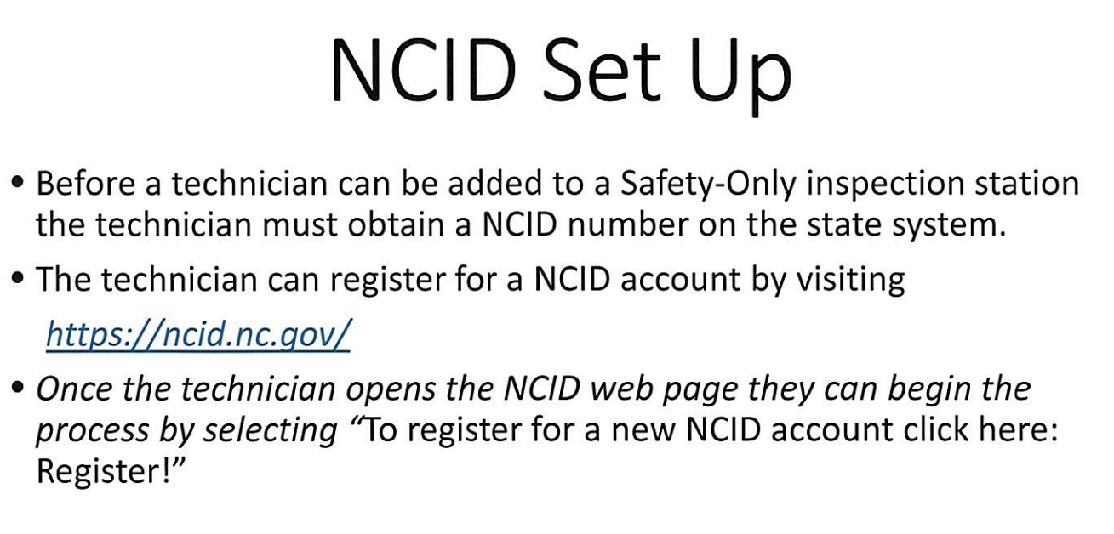

Step # 2
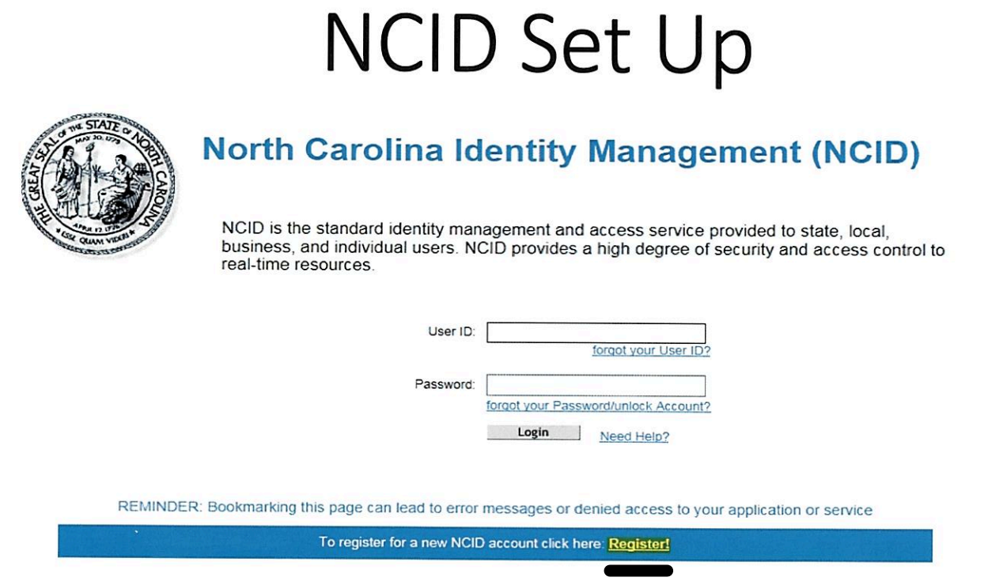

Step # 3
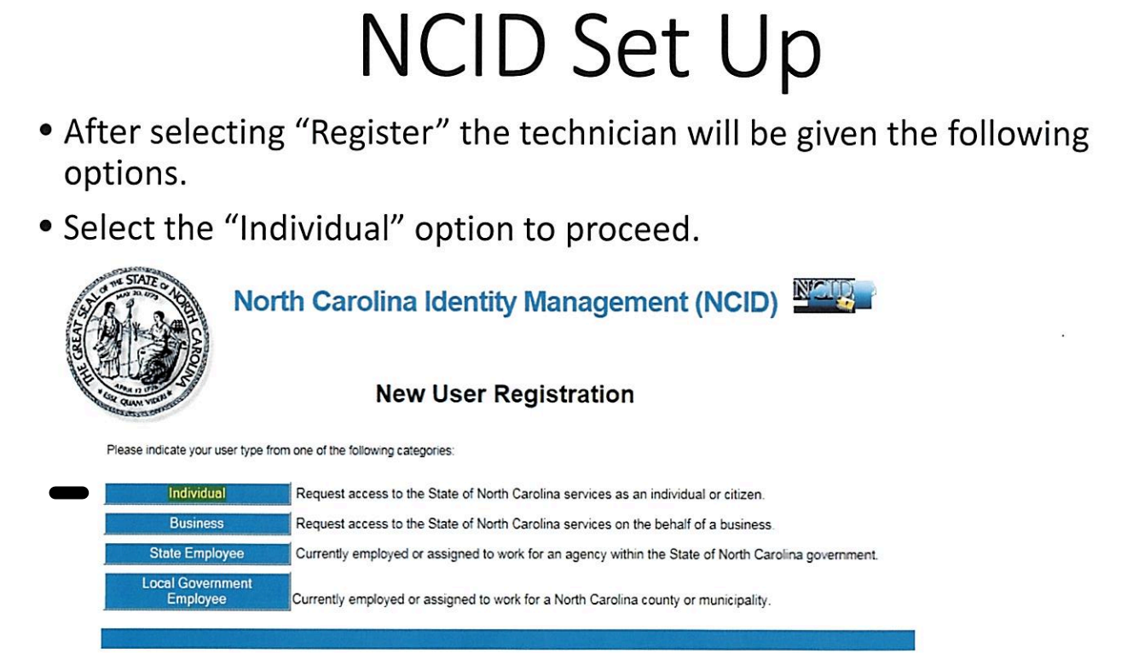

Step # 4
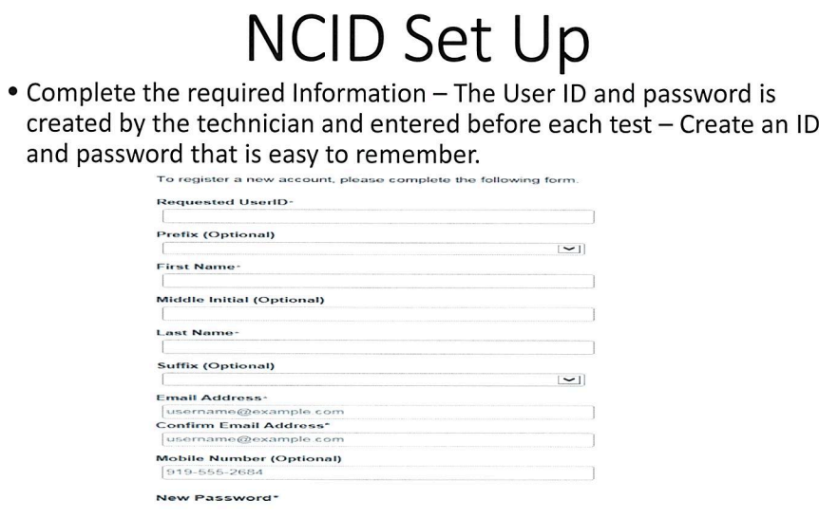

Step # 5 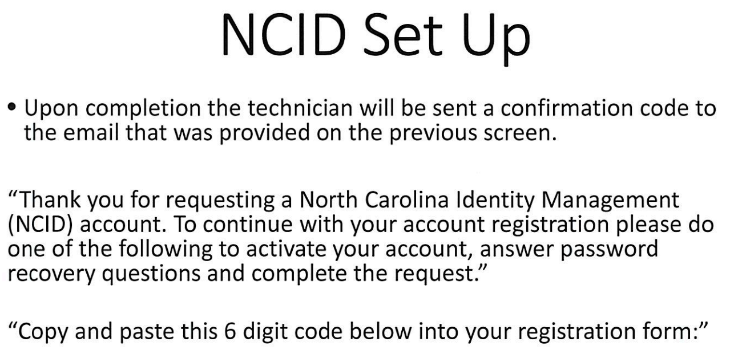

Step # 6
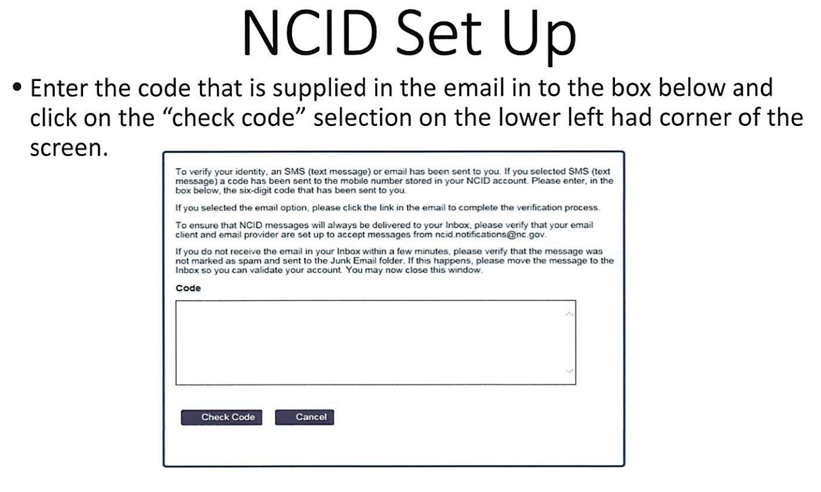

Step # 7
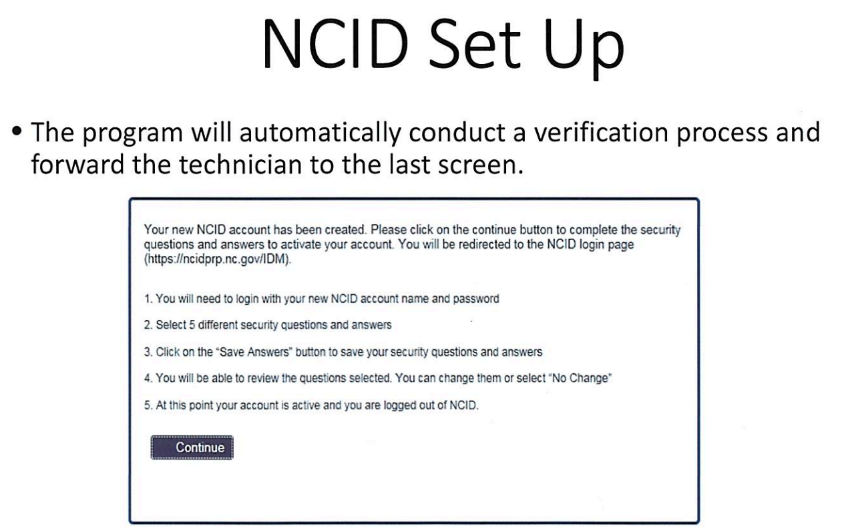

Step # 8

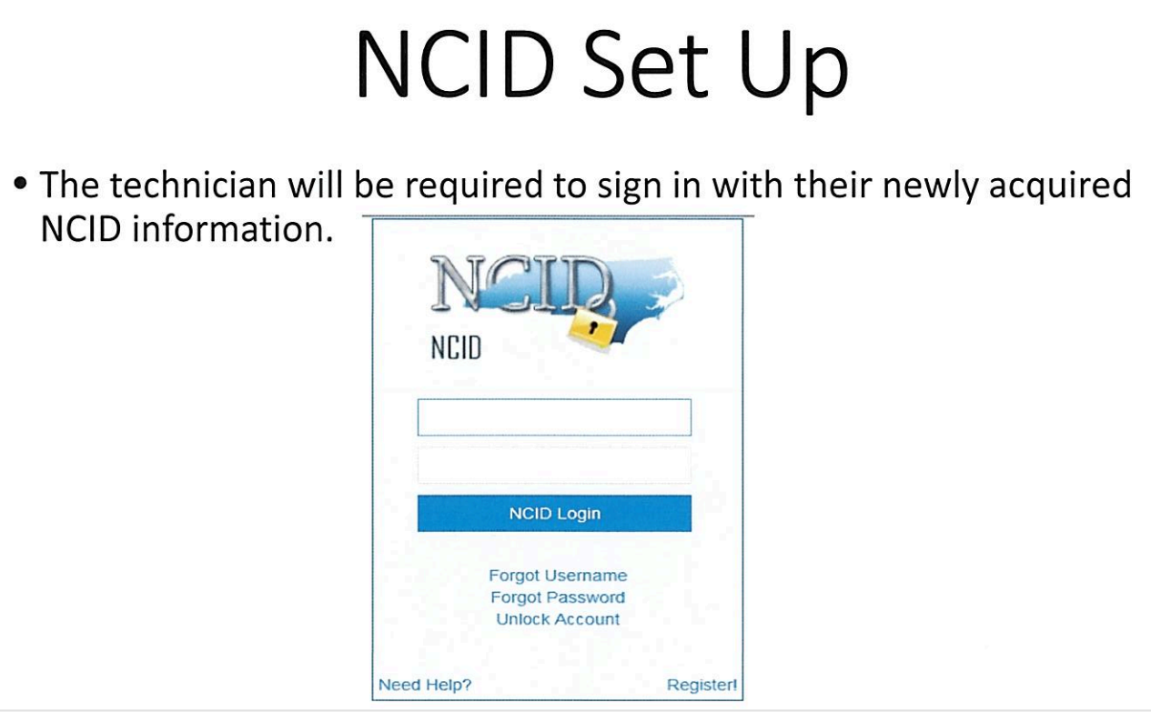

Step # 9

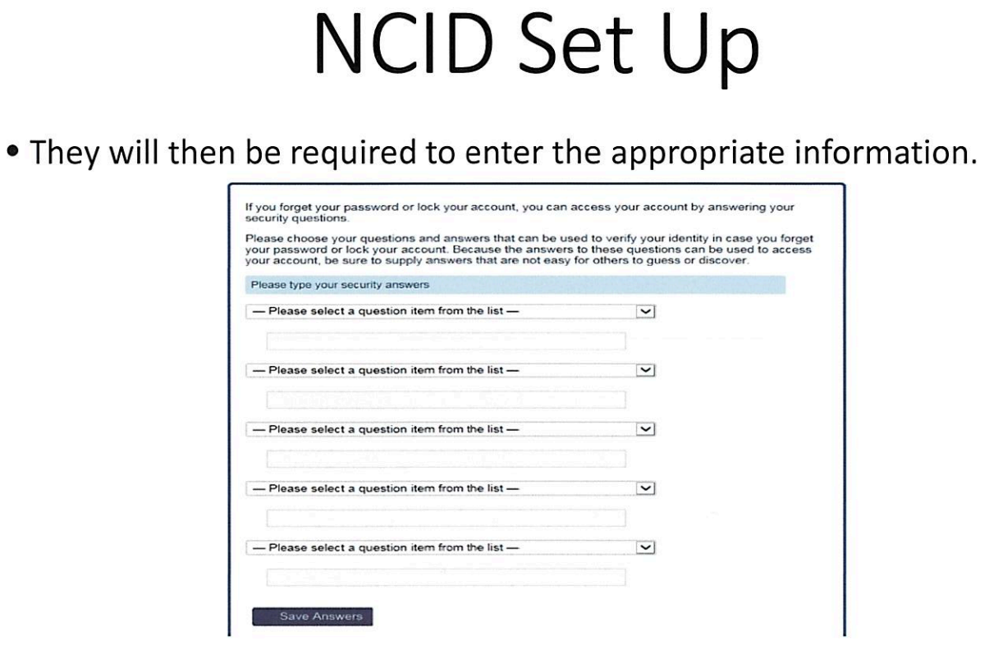

Step #10

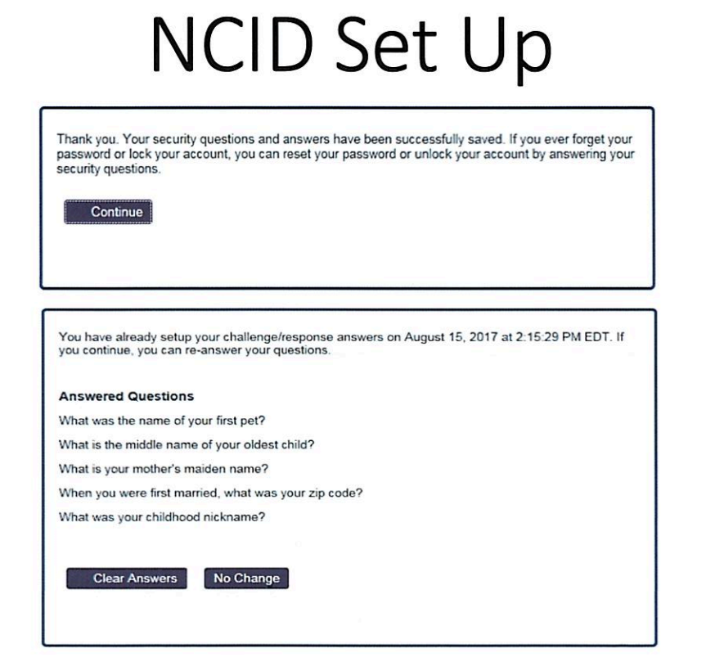

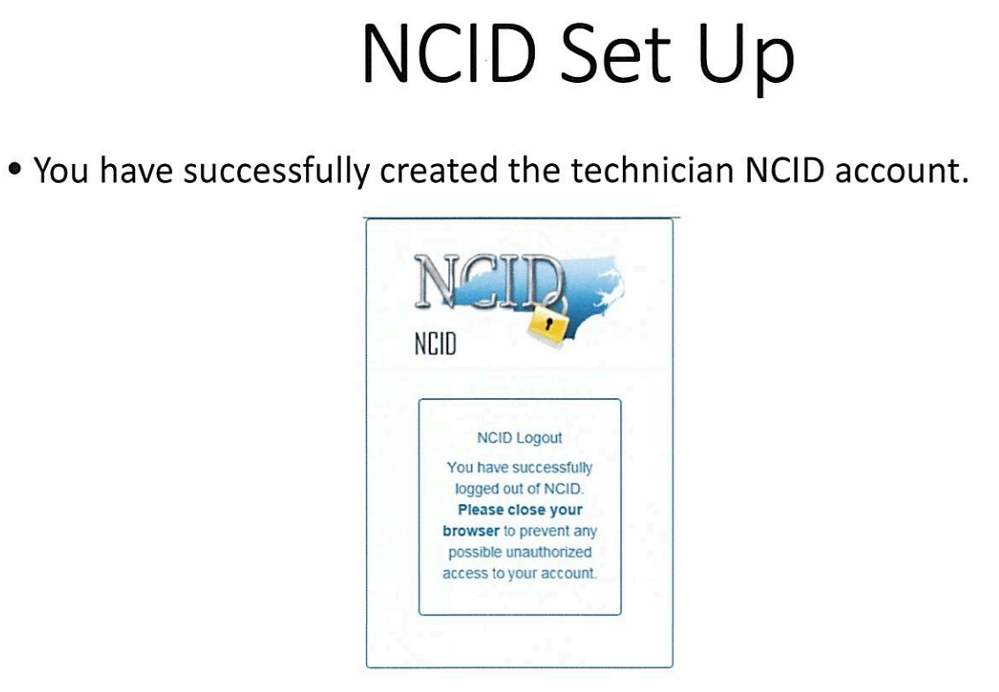

Conclusion

The Safety Inspection Program is the certified Inspection Mechanic training program for the State of North Carolina. The lesson plan utilizes State Law, Administrative Code, and skills needed to conduct a safety inspection. The Inspection Mechanic will be able to identify serious deficiencies that require a failure of the State’s Vehicle Safety Inspection. By identifying equipment problems during the inspection, vehicle owners will be required to have these issues corrected before passing the required annual inspection. The conscientious Inspection Mechanic is the first line of defense to ensure that vehicles registered in this state and operated upon our streets and highways meet at least the minimum safety requirements.

