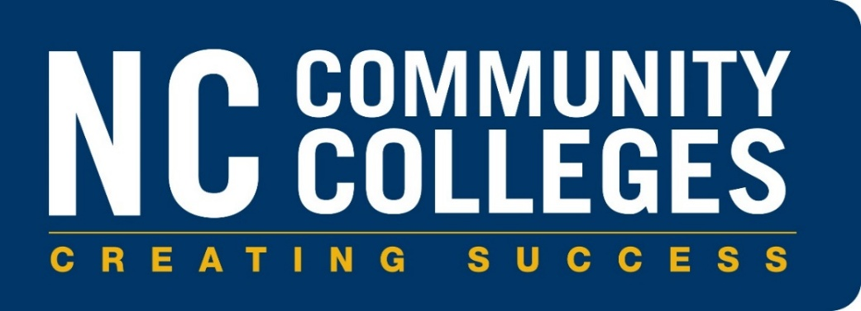

CURRICULUM PROCEDURES REFERENCE MANUAL

Section 3D

Curriculum Program Application for
Residency Licensure Certificate Program and
Educator Preparation Program (EPP) Status

Implementation, September 2022

Originally Approved by the State Board of Community Colleges on July 15, 2022; Revised SBCC 01/16/2026
North Carolina Community College System

Curriculum Program Application Procedures and Application for

Residency Licensure Certificate Program and

Educator Preparation Program (EPP) Status

The State Board of Community Colleges is authorized to approve curriculum programs (1D SBCCC 400.6(a)(1)).

The State Board delegates to the President of the North Carolina Community College System the authority to grant a college the approval to award the associate degree, diploma, or certificate for program titles that have been approved for this delegation by the State Board of Community Colleges based upon a widespread immediate need for the job training and minimal impact upon other colleges. (1D SBCCC 400.6 (4))

Program Approval Procedure - Residency Licensure Certificate and Educator Preparation Program (EPP) Status

Colleges with Current EPP Status
Community colleges must receive State Board of Community College (SBCC) approval to offer any Residency Licensure Certificate. Once approved, the NCCCS EPP State Director will inform the NC Department of Public Instruction of any new Residency areas added for each college.

Colleges Without Current EPP Status
Community colleges must receive State Board of Community College (SBCC) approval to offer the Elementary Education Residency Licensure Certificate. Additionally, community colleges must also receive approval as an Educator Preparation Provider from the State Board of Education (SBE). Consultation with the NCCCS EPP State Director is necessary prior to seeking program approval.
Required Documents
The following documents must be submitted to the System Office Director of Academic Programs in order to initiate the approval process:

- NCCCS EPP Residency Request Form (signed by the president of the community college and the local board of trustee chair)
- Institutional Certification
- Copy of local Board minutes
- Copy of the Program of Study

Upon receipt of the required application documents, the NCCCS EPP State Director will submit the request to the System President for approval through his/her delegated authority granted by the State Board of Community Colleges (SBCC). The program application will be presented at the next SBCC meeting for final approval. Once a college receives approval from the SBCC, a letter of program approval will be issued to the requesting college president and chief academic officer. The college should then enter the program of study (POS) electronically and will be able to offer the program. Approval of the electronic POS must be received prior to implementation of the program.

For Colleges Without Current EPP Approval
Following approval to offer the Residency Licensure Certificate, community colleges must also receive NC State Board of Education (SBE) approval to operate as an Educator Preparation Provider (EPP). The NCCCS EPP State Director will submit the required documentation and coordinate the final steps for EPP status approval with the SBE.
Once a college receives approval from the SBCC and the SBE, a letter of program approval will be issued to the requesting college president and chief academic officer. The college should then enter the program of study (POS) electronically and will be able to offer the program. Approval of the electronic POS must be received prior to implementation of the program.

Submission of Program Application:
Colleges seeking curriculum program approval must submit an application using the attached procedures. All items must be completed and documented as indicated before the program can be considered for approval by the State Board.

The application with original signatures should be submitted to: programs@nccommunitycolleges.edu

Deadlines:
Program applications presented by the 1st of each month will be presented at the NC SBCC the following month. The application will then be presented to the SBE the following month.

Example Timeline
March 1 Complete application received by System Office
April SBCC Meeting System Office presents to SBCC
May SBE Meeting NCCCS EPP State Director submits to SBE

The program approval process for applications which are received after the first working day of the month, are incomplete, or require further analysis may exceed this schedule. The SBCC normally does not meet in June or December, application processing schedules which include these months may exceed schedule.

The EPP status approval process is subject to SBE agendas and timelines.

Annual Data Reporting
There will be three rounds of data reporting each academic year to the following institutions:
- NC Department of Public Instruction
- Educational Testing Services (ETS)
- Title II

Each college will be given instructions on completing each data cycle. Due dates and timelines for data reporting will be provided during monthly NC DPI EPP meetings, monthly Community College EPP meetings, and through the EPP listserv. Additionally, the college will provide data to the NC Community College System Office when requested.

Proposed Program of Study
The proposed program of study should be designed to be in compliance with the curriculum standards approved by the State Board of Community Colleges. The State Board approved curriculum standard for each program is located at: https://www.nccommunitycolleges.edu/college-faculty-staff/academics/programs/curriculum-standards/

The proposed program of study should also be designed using the approved NCCCS Cultivating Carolina Classrooms framework. Please contact the NCCCS EPP State Director to receive a copy of the framework.

Note: The use of Cooperative Curriculum Agreements is not permitted with this program.

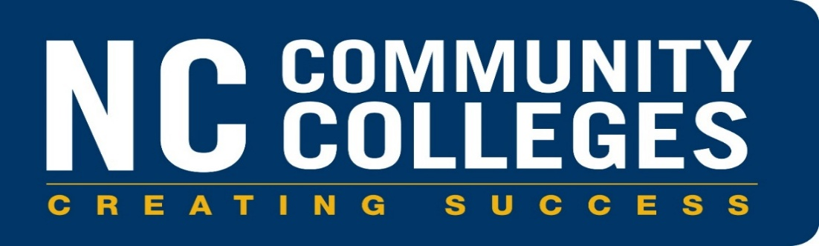

RESIDENCY LICENSURE CERTIFICATE PROGRAM APPLICATION

College ______________________________________________________________________

Licensure Area_________________________________________________________________

Program Code __ __ __ __ __ __

Proposed Semester and Year of Implementation

____ Spring _____ Summer _____Fall 20__ __

Contact Person Name: _________________________________________________

Contact Person Title: _________________________________________________

E-mail ___________________________________

Phone (______)____________________ Extension ________

*The use of Cooperative Curriculum Agreements is not permitted with this program.

NC Community College Educator Preparation Program (EPP) Residency Request Form

For College Completion:
Please indicate the licensure area for which the college is applying.
Elementary Education Residency Licensure Certificate (C55490)

Birth through Kindergarten Residency Licensure Certificate (C55500)

High School Math Residency Licensure Certificate (C55510)

High School Science Residency Licensure Certificate (C55520)

Middle School Math Residency Licensure Certificate (C55530)

Middle School Science Residency Licensure Certificate (C55540)

Special Education Residency Licensure Certificate (C55550)

Please indicate below the requested effective term for the program:
Fall: ____ Spring: ____ Summer: _____ Year____

Institutional Certification

The Residency Certificate curriculum program will enhance the workforce of North Carolina and will provide educational and training opportunities consistent with the mission of the college.

______________________________________________________________________________
(Community College Name)

has assessed the need for this program. The college has examined the facilities and resources required to maintain a viable program and certifies that the college can operate this program efficiently and effectively within the facilities and resources available to the college.

The college will provide master’s degree credentialed faculty for each course provided under the Residency Licensure Certificate Program.

Residency Licensure Certificate Program
Please indicate (by checking) that the community college certifies the ability to:

Implement Residency Licensure Certificate Program in compliance with

the approved NCCCS Cultivating Carolina Classrooms program framework

Implement standardized student learning outcomes and key assessments

Submit annual program reporting data

Submit required program and student documentation and assessment

Provide coaching support throughout program duration

Supervise field experience and complete student observations

____________________________________________________ _____________________
Signature, President of College Date
_____________________________________________________ _____________________
Signature, Board of Trustees Chair Date

Please email completed form and any accompanying documents to: programs@nccommunitycolleges.edu
Proposed Program of Study
Complete the following to indicate the proposed program of study.

MAJOR HOURS

Core
The core is comprised of specific courses and/or subject areas which are required for each curriculum program. These are identified on the curriculum standard for each program. The program of study should reflect the approved framework approved by the NC SBE.

The following course(s) are required:
Course Number Course Title (Credit)

Total Major Semester Hour Credits_____

