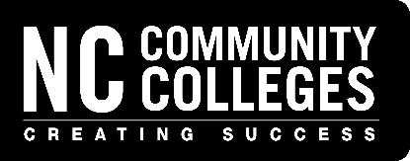

North Carolina State Highway Patrol
Vehicle Safety and On-Board Diagnostics (OBD) Emissions

Registration Form
2026 Instructor Certification Training

DMV Vehicle Inspection Certification Coordinator - Contact Information

Coordinator’s Name:

Community College:
Phone Number:

Email Address:

To register your instructors, please specify their name(s) and desired date(s) in the space below: instructor

Attendee’s Name/Email | Pitt CC |  |  | Central Piedmont |  |  | Wake Tech CC
Attendee’s Name/Email | Safety | OBD |  | Safety | OBD |  | Safety | OBD
Example: Jane Doe  janedoe@email.com | Mar  4 | Mar  5 |  | June3 | June4 |  | Sept 23 | Sept  24

All training classes will be held 8:30 a.m. – 5:30 p.m. at the college indicated.
Troopers from North Carolina State Highway Patrol, Investigative Services Unit – Inspections Section will instruct the classes.

Complete this registration form and send it as an email attachment to Nicholas Rogers

rogersn@nccommunitycolleges.edu

